**CALL CENTER SIMULATION IN NS-3 AND CALL CENTER APPLICATION IN NODE.JS**

**Department of Electrical Engineering,**

**Syed Babar Ali School of Science and Engineering,**

**Lahore University of Management Sciences, Lahore, Pakistan**

By

**Ammarah Azmat Bajwa Roll No: 18100243**

**Hira Tariq Roll No: 18100215**

**Zarmeen Khan Roll No: 18100273**

**Muhammad Shamaas Roll No: 18100217**

A report submitted in partial fulfillment of the requirements for the degree of

**BS Electrical Engineering**

Syed Babar Ali School of Science and Engineering,

Lahore University of Management Sciences

Under the supervision of

**Dr. Tariq Mahmood Jadoon Dr. Ijaz Haider Naqvi**

Designation: Associate Professor Designation: Associate Professor

Email: jadoon@lums.edu.pk Email: ijaznaqvi@lums.edu.pk

Date: 22 May 2018

**Advisor (Dr. Tariq Mahmood Jadoon)**

_______________________________  
[jadoon@lums.edu.pk](mailto:jadoon@lums.edu.pk)

**Co advisor (Dr. Ijaz Haider Naqvi)**

_______________________________

[ijaznaqvi@lums.edu.pk](mailto:ijaznaqvi@lums.edu.pk)

Contents

**List of figures** vi

**List of tables** viii

**Acknowledgments** ix

**Chapter 1** 5

**Problem Statement** 5

**Chapter 2** 6

**Back ground and related work** 6

**2.1 Background** 6

2.1.1 Continuous Time Markov Chain 7

2.1.2 M/M/1 Queue 9

2.1.3 M/M/∞ Queue 10

2.1.4 M/M/1/K Queue 11

**2.2: Related Work** 12

2.2.1 Erlang C 13

2.2.2 Erlang X 14

**Chapter 3** 15

**Design Methodology And Tools** 15

**3.1: System level design** 15

**3.2: Design Methodology** 16

**3.3: Tools** 17

**3.3.1: NS-3** 17

3.3.1.1: Initial System Model: Erlang C 17

3.3.1.2: Improved System Model: Erlang X 22

**3.3.2: Node.js** 27

3.3.2.1: Hypertext Preprocessor/ Active Server Pages protocols 29

3.3.2.2: Secured Network 30

3.3.2.2.1: Secure Hyper Text Transfer Protocol 31

3.3.2.2.2: Transport Layer Security 32

3.3.2.2.3: Digital Certificates 34

3.3.2.2.4: The Public/ Private Key 35

3.3.2.2.5: Perfect Forward Secrecy 36

3.3.2.3: Javascript Session Establishment Protocol 37

3.3.2.4: WebRTC 38

3.3.2.4.1: Standards and protocols 38

3.3.2.4.2: WebRTC Support Summary 38

3.3.2.4.3: WebRTC Applications 39

3.3.2.4.4: Media Stream 40

3.3.2.4.5: RTC Peer Connection 40

3.3.2.4.6: Interactive Connectivity Establishment 41

3.3.2.4.7: RTC Data Channel 42

3.3.2.4.8: Signaling 42

3.3.2.5: Global Functionality of Call Center 43

3.3.2.6: Server Code 44

3.3.2.7: Call Center Home Web Page 45

3.3.2.8: Caller Web Page 46

3.3.2.9: Agent Web Page 47

3.3.2.10: Additional Features 48

**Chapter 4** 49

**Design, simulation and implementation results** 49

**4.1: Finalized System Model: Real Call Center** 49

**4.2: Factors Influencing the Choice of Final Design** 50

**4.3: Final System Diagram** 53

4.4.1: Caller Node Application 58

4.4.2: Distributor Node Application 59

4.4.3: Agent Node Application 60

**4.5: DesignResults** 61

**4.5.1: Erlang C Block Diagram** 61

**4.5.2: Erlang X Block Diagram** 61

**4.5.3: Real Call Center Block Diagram** 62

**4.6: Simulation Results** 63

4.6.1: Erlang C 63

4.6.2: Erlang X 64

4.6.3: Real Call Center 65

4.6.4: Data Analysis 71

4.6.5: Various Routing Schemes 73

**4.7: Implementation Results** 74

4.7.1: Node.js Call Center 74

**4.8: Discussion** 76

**Chapter 5** 77

**Cost Analysis** 77

**Chapter 6** 78

**Societal Relevance** 78

**Chapter 7** 79

**Environmental impact and sustainability** 79

**Chapter 8** 80

**Conclusion and future recommendations** 80

**References** 81

**Appendix** 83

NS-3 Simulation 83

Online Erlang C Calculator [2] 84

Online Erlang X Calculator [3] 84

**NS-3 Code** 86

Distributor Queue 87

Caller Application 88

Receiver Application 89

Distributor Application 90

Agent Application 91

Main 92

**Node.js Code** 94

App.js 94

Caller.html 96

Agent.html 98

CallCenter.html 100

# **List of figures**

Number Page

Figure 1: Continuous Time Markov Chain 7

Figure 2: M/M/1 Queue Markov Chain 9

Figure 3: M/M/∞ Queue Markov Chain 10

Figure 4: M/M/1/K Queue Markov Chain 11

Figure 5: Erlang C Formula for Average Queue Waiting Time versus Number of Agents [33] 13

Figure 6: Real Call Center Model 15

Figure 7: Erlang C Caller Node Application 19

Figure 8: Erlang C Distributor Node Application 20

Figure 9: Erlang C Agent Node Application 21

Figure 10: Erlang X Caller Node Application 24

Figure 11: Erlang X Distributor Node Application 25

Figure 12: Erlang X Agent Node Application 26

Figure 13: Node.js Call Center Block Diagram 27

Figure 14: Node.js Event Loop [36] 29

Figure 15: TLS Handhsake betwwen Server and Client [35] 33

Figure 16: Privacy Enhanced Mail Certificates, Public Key Cryptography Standard #12 file, Personal Information Exchange Certificate and Private File for HTTPS Encryption 34

Figure 17: TLS Key Exchanges [35] 35

Figure 18: Perfect Forward Secrecy [35] 36

Figure 19: JSEP Architecture [34] 37

Figure 20: WebRTC Architecture [34] 39

Figure 21: Framework for finding ICE Candidates [34] 41

Figure 22: Call Initiation Chain [34] 43

Figure 23: Call Center Home Web Page 45

Figure 24: Caller Web Page 46

Figure 25: Agent Web Page 47

Figure 26: Call Center Records 49

Figure 27: Distribution of Call Durations 51

Figure 28: Distribution of Queue Waiting Times 51

Figure 29: Distribution of VRU Durations 52

Figure 30: Call Center Block Diagram 53

Figure 31: Virtual Response Unit Linked List 54

Figure 32: Callers Queue Linked List 54

Figure 33: Caller Node Application 58

Figure 34: Distributor Node Application 59

Figure 35: Agent Node Application 60

Figure 36: Erlang C Queue 61

Figure 37: Erlang X Queue with Abandonments 61

Figure 38: Real Call Center Block Diagram 62

Figure 39: Virtual Response Unit Linked List 62

Figure 40: Real Call Center Queue 62

Figure 41: Erlang C Simulation and Calculator Graph 63

Figure 42: Erlang X Simulation and Calculator Graphs 64

Figure 43: Number of Arivals per Hour 65

Figure 44: Average Queue Waiting Time: Actual Data vs Simulation Results 65

Figure 45: Average Queue Waiting Time: Actual Data vs Simulated Results 66

Figure 46: Average Wait Time: Actual Data vs Simulated Results 66

Figure 47: Real Call Center: Abandonment vs Agents Available and Number of Calls Arriving per Hour for 1 year 67

Figure 48: Real Call Center Simulation with Skill Based Routing: Abandonment vs Agents Available and Number of Calls Arriving per Hour for 1 year 68

Figure 49: Correlation between Real Call Center and NS-3 Simulation 69

Figure 50: Comparison of Routing Schemes: Fastest Server First (Upper Left), Longest Idle First (Upper Right), Lowest Cost Routing (Lower Left), Skill Based Routing (Lower Right) 70

Figure 51: Comparison of Routing Schemes 73

Figure 52: Degradation of Network Performance with increase in Traffic 74

Figure 53: NetAnim Simulation 83

Figure 54: Erlang C Calculator 84

Figure 55: Erlang X Calculator 84

Figure 56: NS-3 Call Center Log File 85

Figure 57: Node.js Call Center Log File 85

# **List of tables**

Number Page

Table 1: Profiles of Agents 52

Table 2: Erlang C Simulation and Calculator Results 63

Table 3: Erlang X Simulation and Calculator Results 64

Table 4: Real Call Center Simulation: Calculated Performance Metrics 72

Table 5: Comparison of Routing Schemes 73

Table 6: Comparison of Node.js Call Center Performance with NS-3 Simulation 75

# **Acknowledgments**

The authors wish to express sincere appreciation to Dr. Tariq Mahmood Jadoon and Dr. Ijaz Haider Naqvi for their supervision during the course of this senior project and in the preparation of this manuscript.

# **Chapter 1**

### **Problem Statement**

This project attempts to realistically simulate a Packet Switched Call Center in NS-3 by incorporating call abandonment, heavy call traffic, call drops and skill based routing. In order to find the deficiencies of our Call Center Simulation, we developed a Call Center Web Application in Node.js to study the effects of network congestion, variable propagation delays and transmission speeds on Quality of Service.

# **Chapter 2**

### **Back ground and related work**

### **2.1 Background**

Call center modeling is a growing research field. They are an example of queuing systems. Queuing models help estimate ways to optimize staffing and maximize performance in a call center. We used NS-3, which is a discrete event network simulator, for our modeling. Calls arrive, wait in a virtual queue and then they are serviced via a routing mechanism. The most common model used at large by both practitioners and academics is the Erlang C model. The model however works under many assumptions mainly: calls arrival follows a Poisson distribution with a known average rate, callers wait infinitely without abandoning the call. Erlang X: an extension of Erlang C is more complex and realistic as it incorporates call abandonment, heavy call traffic; call drops and skill based routing. We attempted to improve Erlang X with additive variables, which makes it close to a realistic call center. We verified it by comparing simulation results against the performance records of a real call center.

In order to model our Call Center, we will need to understand the “Standard Queuing Model” which is based on two assumptions. First, all the agents are assumed to be "homogenous" in their services i.e. having same set of skills and speed to answer the call. Secondly, calls routing is done in such a way that the call is forwarded to the agent who is idle for the longest interval of time. This oversimplification affects the performance of the call center by increasing the average waiting time of the queue. In his paper [13], the author Thomas R. Robbins has highlighted the issues in the oversimplified queuing model and has suggested another routing scheme for the call center environments. Queuing system is implemented in all the call centers. If the agent is busy then the call is placed in the queue and waits there until the agent gets free. Mostly call centers are observed as having a "standard queuing model" which is an oversimplification of the practical call center [12], [5]. However, the performance can be enhanced by introducing some changes in the routing scheme. Agent requires particular skills in handling a certain call efficiently, which depend on their experience as well. More the experience of the agent in handling calls lesser will be the time he will take to service the call, thus the average waiting time in the queue will decrease [13]. Robbins has suggested "experience-based routing" during the peak hours that is when the call arrivals are high then the calls should be delivered to the experienced agents so that they can efficiently manage the load by servicing the calls in lesser time. However, when the arrival rate of calls is small then, according to Robbins, calls should be routed to the non-experienced agents so that they can learn how to service the calls and could gain some experience. This routing scheme not only improves the "system performance" and the "customer service" but also enhance the learning of the newly hired agents [4].

Call Center is analytically modeled using continuous time Markov Chain that we will discuss briefly now.

### 2.1.1 Continuous Time Markov Chain

A Call Center can be modeled using a Markov Chain as shown in Figure 1 where the number of the state represents the number of callers waiting in the Queue. It has the unique property of memorylessness where we can make predictions about future of the process based on the present state only. The call arrivals and service are assumed to have a Poisson distribution that expresses the probability of a given number of events occurring in a fixed interval of time if these events occur with a known constant rate and independently of the time since the last event [8].

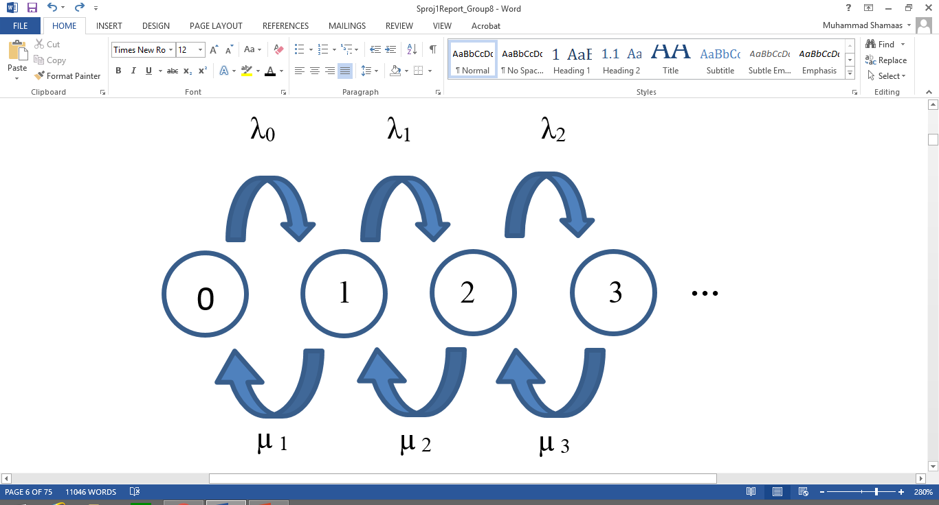

Figure 1: Continuous Time Markov Chain

The Probability of being in state j at time n = π j (n).

Transition Probability P (Xn+1=j | Xn=i) = p i, j (n)

q i, j (n) =

Arrival rate of Calls in state j = λ j = q j, j+1 (n)

Service Rate of Calls in state j =μ j =q j, j-1 (n)

q j, j = - (λ j + μ j)

Time Evolution ofπ j (t) = $\frac{d π_{j} (t)}{dt}$ = q j, j (t)π j (t) + k, j (t) π k (t)

For Stationary State π j (t) = π*j, = 0 and $\sum_{j}{π_{j}}$ =1

The solution of these j differential equations gives the following probability distribution:

Stationary State Probability of state j = π* j = π*0

If = e-λt which is the Poisson Distribution Formula

Now we will discuss three different Markov Chains; M/M/1 Queue, M/M/∞ Queue and the M/M/1/K Queue.

### 2.1.2 M/M/1 Queue

An M/M/1 Markov Chain has Markovian Arrivals and Service with single Queue Server as shown in Figure 2. The Call Arrival Rate = λ and the Call Service Rate = µ. Queue can grow infinitely hence; infinite states are possible [8].

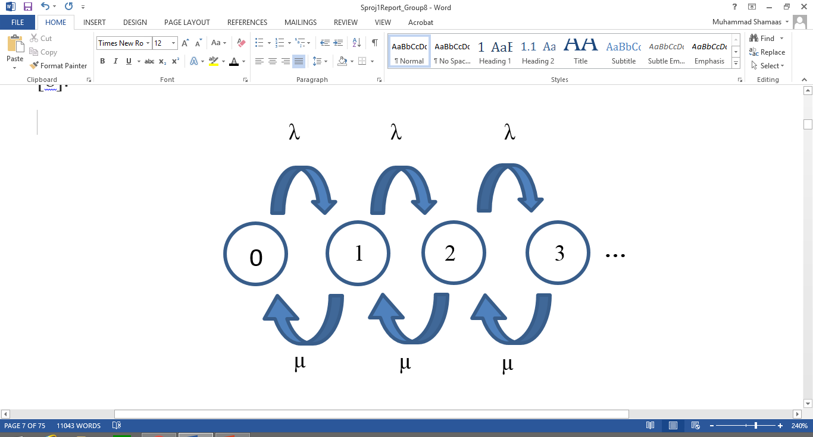

Figure 2: M/M/1 Queue Markov Chain

Stationary State Probability of state j = π*j =

### 2.1.3 M/M/∞ Queue

An M/M/∞ Queue has Markovian Arrivals and Service with separate Queue Server for each Caller as shown in Figure 3. The Call Arrival Rate = λ and the Call Service Rate = nµ where n represents the number of the state. Queue can grow infinitely hence; infinite states are possible [8].

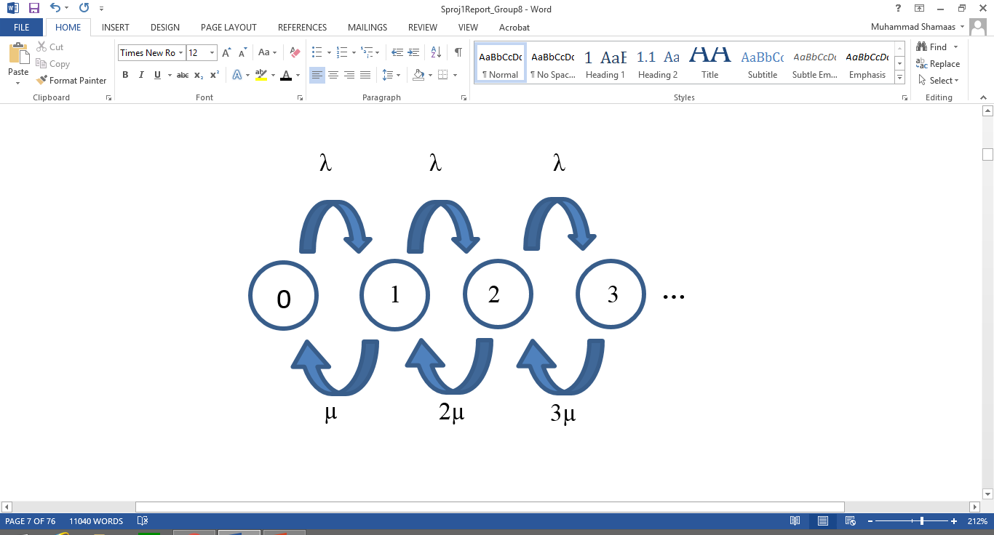

Figure 3: M/M/∞ Queue Markov Chain

Stationary State Probability of state j = π*j =

### 2.1.4 M/M/1/K Queue

An M/M/1/K Markov Queue has Markovian Arrivals and Service with single Queue Server as shown in Figure 4. The Maximum size of Queue = k-1, Call Arrival Rate = λ and Call Service Rate = µ.

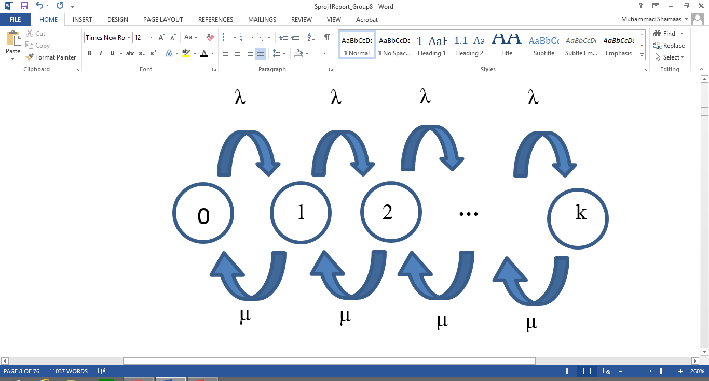

Figure 4: M/M/1/K Queue Markov Chain

Stationary State Probability of state j = π*j = where j ≤ k

### **2.2: Related Work**

Thomas R. Robbins et al. in their paper [13] have compared the queuing models that are widely used in the call center analysis. First is the Erlang C model, many assumptions in the model simplifies it. This model assumes that the agents are “statistically identical” all have the same speed and ability to answer the call. In addition, the calls, which arrive according to the Poisson distribution, are having a known average rate of arrival [8]. Moreover, it assumes that the size of the queue is infinite and calls can wait for any large amount of time inside the queue without abandoning it. It means that the average waiting time could be large enough which is quite unrealistic and can have a drastic impact on the customer service and call center operations. However, in Erlang A model, the extension of the Erlang C model, abandonments are considered. The callers have some finite patience to wait in the queue and if it turns out the caller abandons the queue [7]. “Quality-driven and the Quality and efficiency-driven (QED) regimes”, where the call centers are capable enough to handle all the calls and there is no abandonment, are considered in this paper and the performance metrics for both Erlang A and Erlang C in QED regimes are being compared. Erlang A model though give better results but it does not depict the accurate staffing requirement in the cases when the arrival rates have significant uncertainties [4]. In such cases, Erlang C is used in making the staffing decisions. However, in case of the “Efficiency-driven regime” when the arrival rate is large and all agents are occupied in servicing the calls here the Erlang C model simply is collapsed because there are significant abandonments. Erlang A model, which allows the abandonments, is used to predict the performance metrics in this kind of regime [5].

### 2.2.1 Erlang C

The Erlang C Formula [7] is given below and the plot is shown in Figure 5 [33]:

λ = Number of calls per unit time

b = Average Call Duration

a =  λ * b = Load in Erlang units

s = Number of Agents

For s > a,

Average Waiting Time in Queue = $\frac{C \left(s , a\right) * b}{(s - a)}$

Where Probability of Enqueue = $C\left( s, a\right)=\frac{\frac{{s . a}^{s}}{s! . (s-a)}}{\sum_{i=0}^{s-1}{\frac{a^{i}}{i!}}+\frac{s.a^{s}}{s! . (s-a)}}$

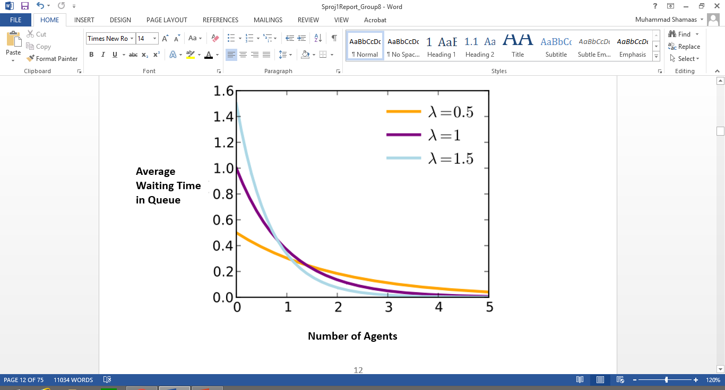

Figure 5: Erlang C Formula for Average Queue Waiting Time versus Number of Agents [33]

### 2.2.2 Erlang X

The Erlang X or Erlang A model builds on the Erlang C Model by including abandonments of callers i.e. Callers can abandon Queue after waiting for some time. It is modeled using M/M/M+N Markov Chain [13]. Packets can be dropped if queue is full which models the limited number of telephone lines available. Calls can require multiple skills and Agents can have multiple skills. Specialists have only one skill whereas Generalists can have two or more skills. All Calls have same Call Duration distribution.

The Analytical Erlang X formula [14] is presented below.

Mean Patience of Callers = θ-1, Arrival Rate = $λ$, Service rate = $nµ$

Gamma Function γ(x, y) = $\int_{0}^{y}{t^{x-1}e^{-t}dt}$, x ≥ 0, y ≥ 0

J = $\frac{e^{λ/θ}}{θ}{(\frac{θ}{λ})}^{\frac{nµ}{θ}}$ γ ($\frac{nµ}{θ}$, $\frac{λ}{θ}$), ɛ = $\frac{\sum_{j=0}^{n-1}{(\frac{1}{j!})({\frac{λ}{ µ})}^{j}}}{(\frac{1}{\left(n-1\right)!})({\frac{λ}{ µ})}^{n-1}}$, P (Wait > 0) = $\frac{λJ}{ɛ+λJ}$ (1- $θ$)

# **Chapter 3**

### **Design Methodology And Tools**

### **3.1: System level design**

The Real Call Center has Abandonments, Call Drops, Dynamic Agents Scheduling, Time varying call arrival rates, heterogeneous agents, Heavy Traffic and Call Retrials as shown in Figure 6, which require much more detailed modeling and calculations.

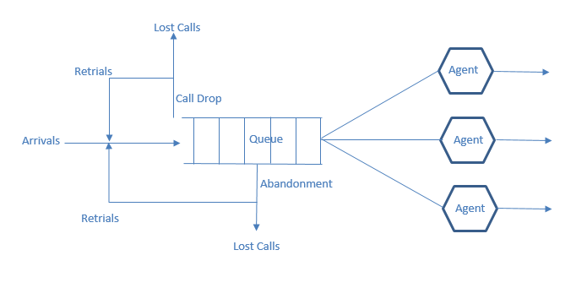

Figure 6: Real Call Center Model

We discussed the various models used for the analytical analysis of the Call Center Queuing Model. Now we will discuss the Simulation Results of our Proposed Model whose foundation is the M/M/N+M/K Queue and which was built to improve the existing Call Center Models. Our goals were:

1. Merge M/M/N and M/M/1/K models to include call drops and multiple Queue Servers.
2. Include Agent Skills and Caller Patience for call abandonments.
3. Incorporate randomness for propagation delays.
4. Perform experiments with simulator and compare results with the industrial models of Erlang C and Erlang X.
5. Iteratively perform simulation optimization to realize actual call center model.

### **3.2: Design Methodology**

The Call Centre structure comprises of three fundamental entities; the Caller Node, the Agent Node and the Distributor Node. Having built a structure for the Agents, we have further differentiated them based on their skills, no of calls serviced and operator number in our model. The callers have been differentiated based on call times, patience tag, waiting time in the queue and the skill type they require. While a common distributor node (buffer) has also been made which Enqueue arriving packets and Dequeue packets to the agent node.

Erlang C is a simple multi-server queuing system; calls arrive according to a Poisson process at an average rate. We verified Erlang C Formula with experimental results for mean waiting time of callers in Queue using the Ger Koole calculator [10], [11]. Our goal is to verify Erlang X with additive variables, which makes it close to a realistic call center through empirical analysis involving comparison of performance with real call center records [9].

Generally, abandonment rates cannot be estimated directly using the Erlang C model because the model assumes no abandonment occurs. Our model will assume that each caller has a finite willingness to wait, and will abandon the queue or hang up if his or her wait time exceeds his or her patience. We plan to achieve this by assigning each caller a patience counter, which is decremented after each second. Erlang X is modeled with limited available number of telephone lines thus calls will be dropped if the waiting queue is full. In addition to finite queue, we route our distributor in such a way that it can pick a blocking packet from anywhere in the queue and send it for service to prevent queue blockage [10], [11]. Furthermore, the agents in our model will also have multiple skills. There are two categories: Specialists, having only one skill and Generalists, having expertise in more than one skill [7]. We conclude by verifying experimentally that even with complex variables, we can achieve optimization in Erlang X just as that in Erlang C.

### **3.3: Tools**

### **3.3.1: NS-3**

We are implementing a Simulation of an Optimized Call Centre Model on NS3 Software, which is a discrete event simulator [6]. We have implemented packet switching in our simulation. This has been done in the software, by allocating a caller node, distributor and Agent Node. As the following is a representation of a more realistic model, so we have implemented Erlang X. It in cooperates queue abandonment of callers, unpredictable call traffic, call drops and skill based routing. Fastest Server First, Longest Idle Server First and Experience Based routings each in different circumstances have been used to service calls in our model [14].

A Caller Node keeps generating IP packets and sends them to the distributor node using a Point-to-Point Link. The Packet length follows a fixed distribution and has a fixed mean value. The Call Skill is denoted by a random variable and is stored in the TOS Tag of the IP Packet. The Caller Patience random variable is stored in the TTL Tag of the IP Packet. This is implemented in NS3 by a function that generates a random variable for Call length, Call Skill and Caller Patience, makes an IP packet of that size, adds the IP Tags and then sends it using a socket. The function then makes a self-call by scheduling the next call after a time interval given by a random number following a negative exponential distribution.

The Distributor Node receives the IP packets and keeps adding them to the tail of the Queue if the Queue is not completely full in which case call is dropped and lost. This is done in NS3 by calling an interrupt to Enqueue function whenever a packet arrives at the socket. It also checks every second if any Agents are idle and distributes the Packets from the Queue to them. It traverses the entire Queue and checks if the idle Agents have the skill required by the Packet. In NS3, it schedules a call to SendPacket function every second, which does the routing of calls using Point to Point Links to Agents with required skill. The Agent Node receive the IP packet from the Distributor Node and becomes busy for the duration of the call. Hence, it changes the Boolean idle flag to zero. While it is busy, it cannot receive any more packets. It schedules a call to ServiceComplete function after a period equal to the length of the call after which it changes its status to idle again.

### 3.3.1.1: Initial System Model: Erlang C

Erlang C is a single Queue server model that is modeled using M/M/N Queue [13] which was discussed earlier. Markovian processes model the Calls arrivals and service. There are N Queue servers or Agents, each with a service rate of µ hence the effective service rate is Nµ. All Agents are homogenous and perfectly efficient at all time. The calls arrive at a fixed rate of λ. The Calls have a mean length and Callers do not hang up. The Callers can wait infinitely for service in the queue i.e. they never abandon the queue. Hence, the queue can build up infinitely and no calls are lost before service.

#### Simulation Methodology

We built the Queue using a chain of Link Structures in NS3. Each Link has a front and back pointer that point to proceeding and preceding Link. The Link is a container for the Call Packet, which is stored as a Packet Pointer. The length of the packet denotes the length of the call hence the Link also stores the Packet Size as a Data element.

struct Link

{

Link * Back;

Link * Front;

Uint32_t Data;

Ptr<Packet> pkt;

}

A Caller Node keeps generating IP packets and sends them to the distributor node using a Point-to-Point Link. The Packet length follows a fixed distribution and has a fixed mean value. This is implemented in NS3 by a function that generates a random variable, makes an IP packet of that size and then sends it using a socket. The function then makes a self-call by scheduling the next call after a time interval given by a random number following a negative exponential distribution.

The Distributor Node receives the IP packets and keeps adding them to the tail of the Queue. This is done in NS3 by calling an interrupt to Enqueue function whenever a packet arrives at the socket. It also checks every second if any Agents are idle and distributes the Packets from the Queue to them. In NS3, it schedules a call to SendPacket function every second, which does the routing of calls using Point to Point Links to Agents.

The Agent Node receive the IP packet from the Distributor Node and becomes busy for the duration of the call. Hence, it changes the Boolean idle flag to zero. While it is busy, it cannot receive any more packets. It schedules a call to ServiceComplete function after a period equal to the length of the call after which it changes its status to idle again.

Next, we discuss the Caller, Distributor and Agent Node Applications designed for this Erlang C Model framework.

#### Caller Node Application

The Erlang C Caller Node Application is shown in Figure 7.

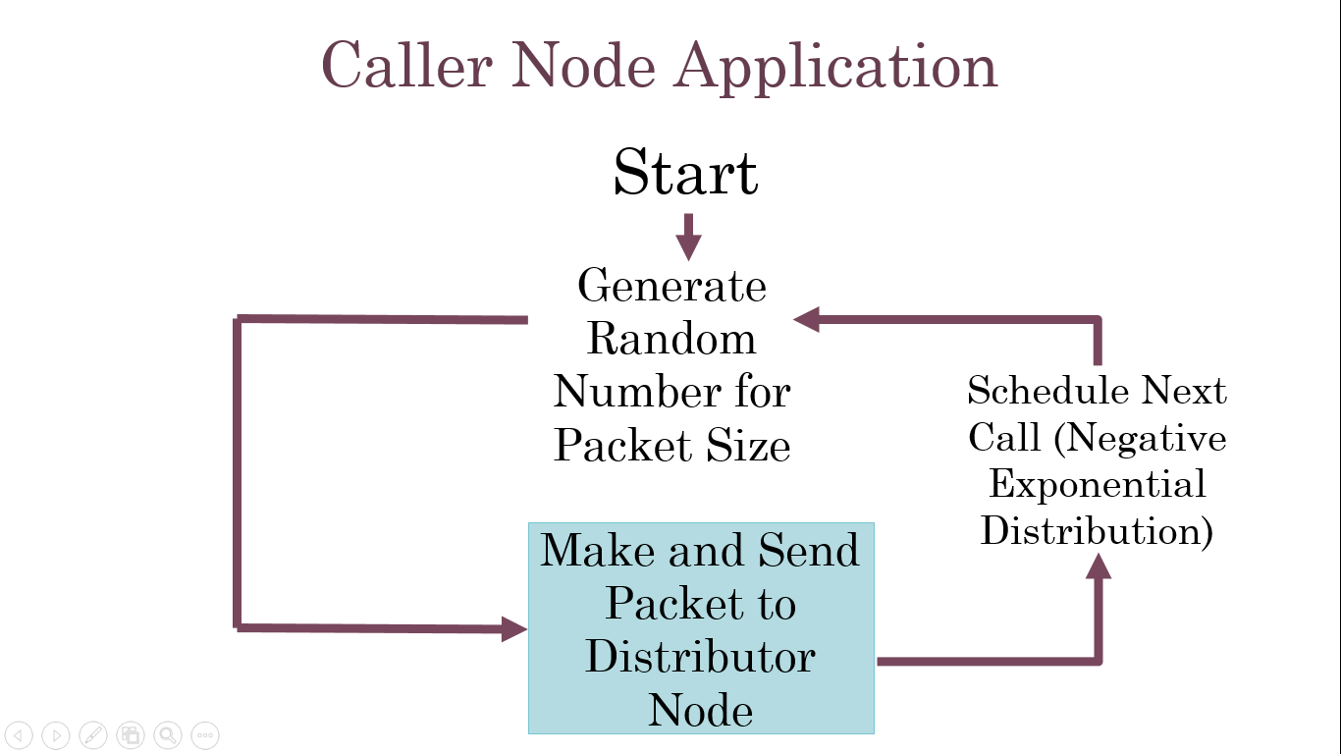

Figure 7: Erlang C Caller Node Application

void SendPacket ()

{…

Size=PacketSizeGenerator->GetInteger (); //Generate Random Size

Ptr<Packet> packet=Create<Packet> (size); //Make Packet

Socket->Send (packet); //Send Packet

Time= InterArrivalTimeGenerator->GetInteger ();

Time tnext (Seconds (Time)); //Schedule self-call

SendEvent=Simulator: Schedule (tnext, &CallerApp: SendPacket, this);

}

#### Distributor Node Application

The Erlang C Distributor Node Application is shown in Figure 8.

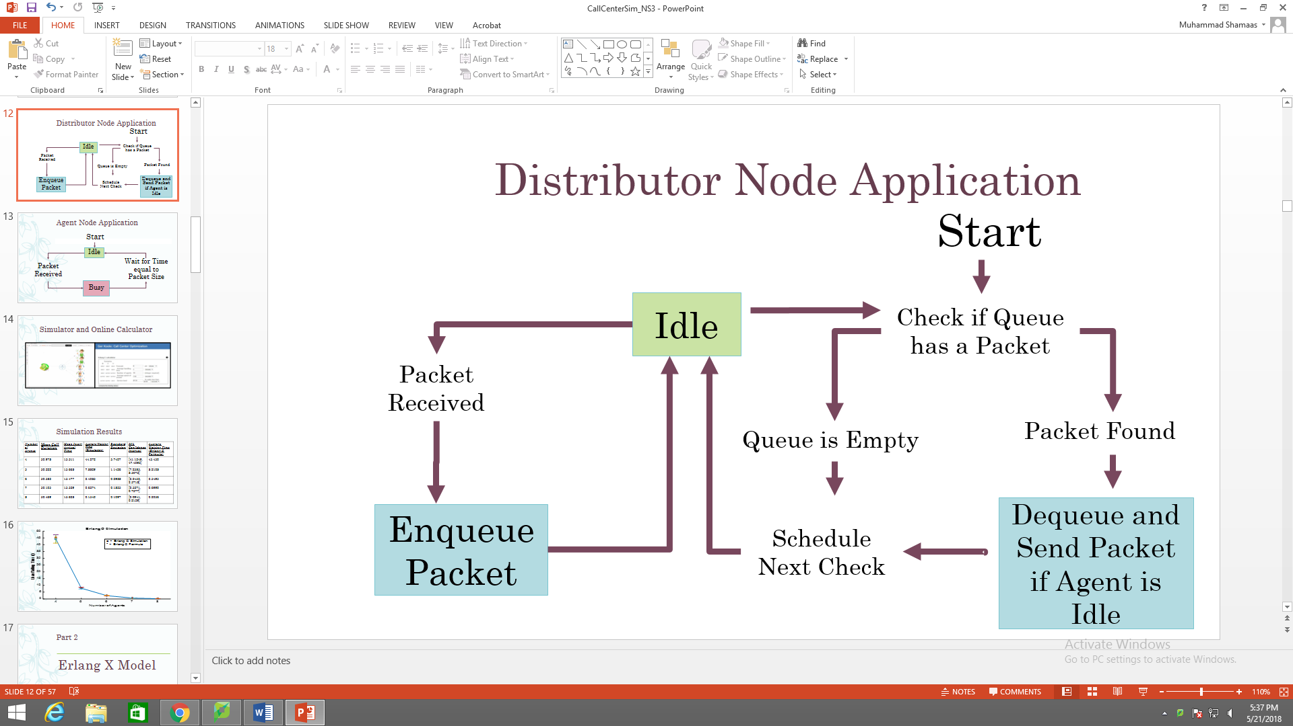

Figure 8: Erlang C Distributor Node Application

void SocketRecv (Ptr<Socket> socket) //Receive Call Back Function

{…

Ptr<Packet> packet=MySocket->Recv ();

Queue->Enqueue (packet); //Enqueue Packet

MySocket->SetRecvCallback (MakeCallback (&DistributorApp: SocketRecv, this));

}

void SendPacket ()

{…

if (idleArray [PeerNumber] && (queue->NumberOfPacketsInQueue>0)) //Check if Agent is idle and Queue has a Packet

{

MyPacket=queue->Dequeue (); //Dequeue Packet

MySocket->Send (MyPacket); //Send Packet to Agent

Time tnext (Seconds (1); //Schedule self-call

SendEvent=Simulator: Schedule (tnext, &DistributorApp: SendPacket, this);

}

}

#### Agent Node Application

The Erlang C Agent Node Application is shown in Figure 9.

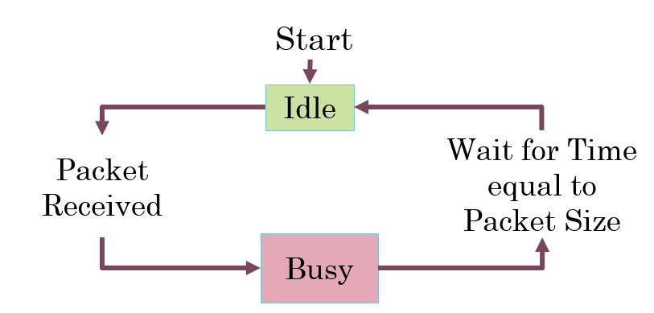

Figure 9: Erlang C Agent Node Application

void SocketRecv (Ptr<Socket> socket)

{…

MyPacket=MySocket->Recv (); //Receive Packet

PacketSize=MyPacket->GetSize ();

IdleArray [OperatorNumber] = 0; //Busy

Time tnext (Seconds (PacketSize)); //Call ServiceComplete after time = PacketSize

SendEvent=Simulator: Schedule (tnext, OperatorApp::ServiceComplete, this);

}

void ServiceComplete ()

{…

IdleArray [OperatorNumber] =1; //Idle

MySocket->SetRecvCallback (MakeCallback (&OperatorApp: SocketRecv, this));

//Call SocketRecv when Packet Comes

}

After Verifying the Erlang C Model, we built the popular Erlang X model, which incorporates call abandonments, call drops, and skill based routing.

### 3.3.1.2: Improved System Model: Erlang X

The Erlang X or Erlang A model builds on the Erlang C Model by including abandonments of callers i.e. Callers can abandon Queue after waiting for some time. It is modeled using M/M/M+N Markov Chain [13]. Packets can be dropped if queue is full which models the limited number of telephone lines available. Calls can require multiple skills and Agents can have multiple skills. Specialists have only one skill whereas Generalists can have two or more skills. All Calls have same Call Duration distribution.

Next, we discuss the implementation details and Simulation Methodology of Erlang X model.

#### Simulation Methodology

Building on the Erlang C model, we modified the Queue Link by keeping a Skill section in each Link to aid distribution of packets to Agents of desired skill. The QueueWaitingTime Element denotes the Maximum time the caller will wait in the Queue before abandoning the Queue.

Struct Link

{

Link * Back;

Link * Front;

Uint32_t Data;

Uint32_t Skill;

Ptr<Packet> pkt;

Time EnqueueTime;

Uint32_t QueueWaitingTime;

}

The Patience Counter of each Link decrements every second. If Timer of a Link hits zero, we remove that Link from Queue. Hence, the caller has abandoned the Queue before being serviced.

void CountDown ()

{…

If (NumberOfPacketsInQueue>0)

{

Link* a =Head;

While (a! =Tail) //Traverse Entire Queue

{

a =a->Back;

a ->QueueWaitingTime--; //Decrement counter

If (a->QueueWaitingTime==0) {a-Back->Front = a->Front ;} // Abandonment

}

}

}

Before Enqueue, we check if queue is full. If queue is full, packet is dropped.

void Enqueue (Ptr<Packet> Packet)

{…

If (NumberOfPacketsInQueue<MaximumQueueLimit) //Check Queue Limit

{

Packet->Front = Tail-> Front;

Tail->Front = packet; //Enqueue

}

Else

{

Myfile<<"Packet Dropped, MaximumQueueLimit Exceeded"<<endl; //Drop

}

}

To prevent one packet from blocking entire queue, we allow distributors to pick packet from any link of queue.

If (idle [PeerNumber] && (queue->NumberOfPacketsInQueue>0))

{…

DistributorQueue::Link* a=queue->Head->Back;

DistributorQueue::Link* b=0;

While (a! =queue->Tail) //Traverse Entire Queue

{

If ((SkillArray [PeerNumber] & a->Skill)>0) //Skill Matching

{

Socket->Send (a->Packet) //Send Packet

}

}

}

Now we discuss the Caller, Distributor and Agent Node Applications designed for this Erlang X Model framework.

#### Caller Node Application

The Erlang X Caller Node Application is shown in Figure 10.

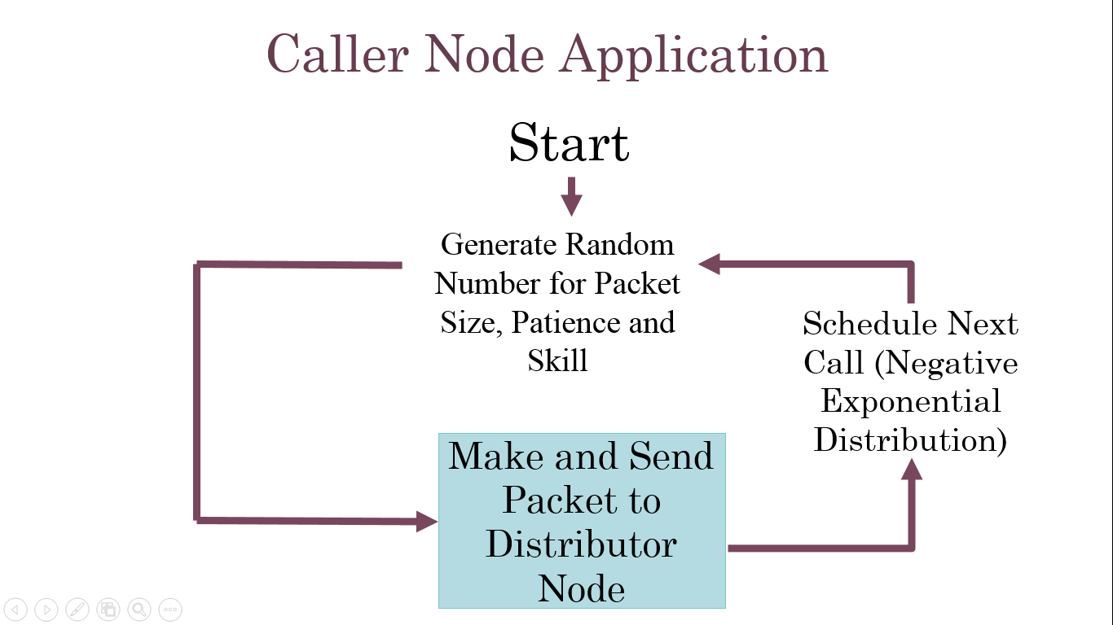

Figure 10: Erlang X Caller Node Application

void SendPacket ()

{…

Size =PacketSizeGenerator ->GetInteger ();

Waitingtime =WaitingTimeGenerator ->GetInteger ();

Skill =SkillTypeGenerator ->GetInteger ();

Time =InterArrivalTimeGenerator->GetInteger (); //Generate Random Numbers

Socket->SetIpTos (skill); //Set Packet Skill

Socket->SetIpTtl (waitingtime); //Set Packet Waiting Time

Ptr<Packet> packet=Create<Packet> (size); //Make Packet

Socket->Send (packet); //Send Packet

Time tnext (Seconds (static_cast<double> (time))); //Schedule self-call

SendEvent=Simulator: Schedule (tnext, &CallerApp: SendPacket, this);

}

#### Distributor Node Application

The Erlang X Distributor Node Application is shown in Figure 11.

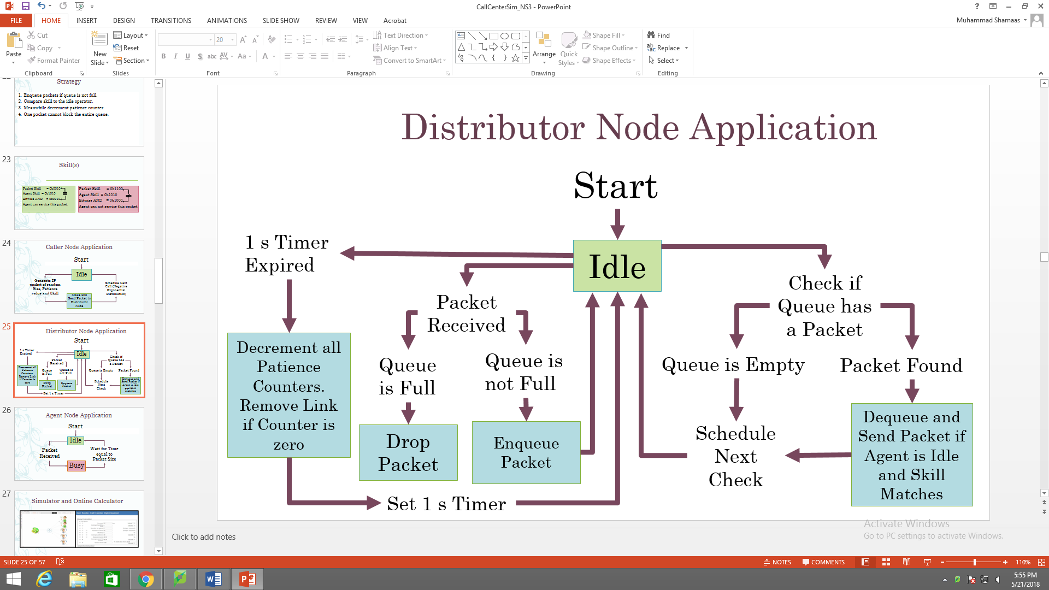

Figure 11: Erlang X Distributor Node Application

void SkillBasedRouting ()

{…

If (idle [PeerNumber] && (queue->NumberOfPacketsInQueue>0)) //Checks

{

DistributorQueue::Link* a=queue->Head->Back;

If ((SkillArray [PeerNumber] & a->Skill)>0) //Match Skill

MySocket ->Send (a->Packet); //Send Packet

Time tnext (Seconds (1)); //Schedule self-call

SendEvent =Simulator::Schedule (tnext, &DistributorApp: SkillBasedRouting, this);

}

}

void SocketRecv (Ptr<Socket> socket)

{…

Address from;

Ptr<Packet> packet=MySocket->RecvFrom (from); //Receive Packet

Queue->Enqueue (packet); //Enqueue Packet

MySocket->SetRecvCallback (MakeCallback (&ReceiverApp: SocketRecv, this));

}

#### Agent Node Application

The Erlang X Agent Node Application is shown in Figure 12.

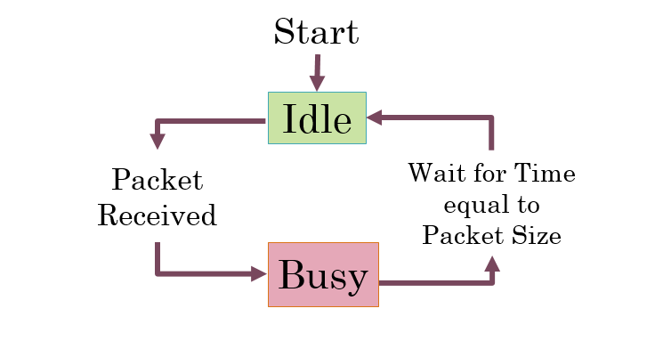

Figure 12: Erlang X Agent Node Application

void SocketRecv (Ptr<Socket> socket)

{…

MyPacket =MySocket->Recv (); //Receive Packet

PacketSize =MyPacket->GetSize ();

Time tnext (Seconds (PacketSize); //call ServiceComplete after time = Packet Size

SendEvent =Simulator::Schedule (tnext, &AgentApp: ServiceComplete, this);

IdleArray [AgentNumber] =0; //Become Busy

}

void ServiceComplete ()

{…

IdleArray [AgentNumber] =1; //Become Idle

MySocket ->SetRecvCallback (MakeCallback (&AgentApp: SocketRecv, this));

//Call SocketRecv Function when call arrives

}

We built our final Call Centre model by adding retrials, Virtual Response Unit, heterogeneous agents, time varying arrival rates and Agent Schedules.

### **3.3.2: Node.js**

We made an internet based call center application in Node.js [18] which allows users to connect their internet devices to our HTTPS Server using an IP Address and Port, even through firewalls and NATs. The user can choose to become an Agent or a Caller on Home Page. As shown in Figure 13, Signaling for Javascript Session Establishment is done using Socket.io Library [26]. Caller and Agent stream live audio and Files using WebRTC Point to Point Connection [29].

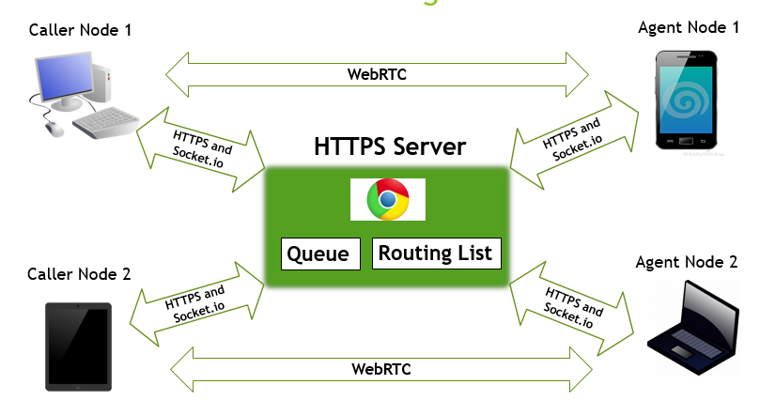

Figure 13: Node.js Call Center Block Diagram

The Node.js application was based on the Call Center Simulation in NS-3. It incorporated all the features of the simulation hence we could replicate IP calls by bidirectional audio calls and exchange of Text messages or Files between Caller and Agent. By collecting data in real time, we could record all the important performance metrics and compare them with our NS-3 Simulator results.

Node.js is single-threaded, non-blocking and asynchronous [18], which is very memory efficient. It works asynchronously to service multiple requests at same time.

We have used Node.js due to the following reasons:

* Node.js is an open source server framework
* Node.js is free
* Node.js runs on various platforms (Windows, Linux, Unix, Mac OS X, etc.)
* Node.js uses JavaScript on the server

In comparison with the synchronous programming the asynchronous programming is time saving, as in case of the synchronous programming, we cannot go to the next line of command until and unless the first line of command is executed completely and properly. While in case of the asynchronous programming multiple lines of commands can be executed at the same time.

Asynchronous programming will avoid freezing of browsers, improved speed of the website applications, improve performance when multiple clients are using web services at the same time. It is effective in case of Fault tolerance. We can get rid of the DOM updates, CSS animation and user interactions (right clicking, text selection etc) getting blocked or frozen.

### 3.3.2.1: Hypertext Preprocessor/ Active Server Pages protocols

PHP is a widely-used, open source scripting language. Scripts are executed on the server. PHP can be used for generating dynamic page content and for performing the file operations like create, open, read, write, delete, and close files on the server. With PHP you are not limited to output HTML. You can output images, PDF files, and even flash movies. You can also output any text, such as XHTML and XML. Active Server Pages enable computer code to be executed by an Internet server [36].

PHP or ASP both are the synchronous protocols and they handle the file request in the following manner:

1. Sends the task to the computer's file system.

2. Waits while the file system opens and reads the file.

3. Returns the content to the client.

4. Ready to handle the next request.

However, Node.js which uses asynchronous programming handles the file request in the following manner and saves a lot more time.

1. Sends the task to the computer's file system.

2. Ready to handle the next request.

3. When the file system has opened and read the file, the server returns the content to the client.

The Node.js Event Loop is shown in Figure 14 [36].

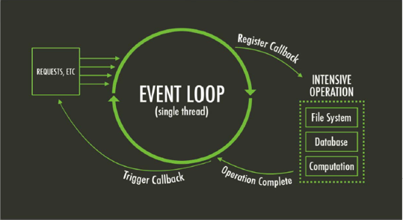

Figure 14: Node.js Event Loop [36]

### 3.3.2.2: Secured Network

SSL (Secure Sockets Layer) and TLS (Transport Layer Security) these are the protocols that ensures privacy between communicating applications and their users on the Internet. TLS is an updated and more secured version of SSL. Both SSL and TLS are used to encrypt confidential data sent over an insecure network such as the Internet. They are the cryptographic protocols that provide [communications security](https://en.wikipedia.org/wiki/Communications_security) over a [computer network](https://en.wikipedia.org/wiki/Computer_network). These standard security technologies establish an encrypted link between a web server and a browser. This link ensures that all data passed between the web server and browsers remain private and integral. The connection is private (or secure) because [symmetric cryptography](https://en.wikipedia.org/wiki/Symmetric_cryptography) is used to encrypt the data transmitted. The [keys](https://en.wikipedia.org/wiki/Key_(cryptography)) for this symmetric encryption are generated uniquely for each connection and are based on a [shared secret](https://en.wikipedia.org/wiki/Shared_secret) negotiated at the start of the session [35].

### 3.3.2.2.1: Secure Hyper Text Transfer Protocol

HTTP Secure (HTTPS) is an extension of the [Hypertext Transfer Protocol](https://en.wikipedia.org/wiki/Hypertext_Transfer_Protocol) (HTTP) for [secure communication](https://en.wikipedia.org/wiki/Secure_communications) over a [computer network](https://en.wikipedia.org/wiki/Network_operating_system), and is widely used on the [Internet](https://en.wikipedia.org/wiki/Internet). In HTTPS, the [communication protocol](https://en.wikipedia.org/wiki/Communication_protocol) is encrypted by [Transport Layer Security](https://en.wikipedia.org/wiki/Transport_Layer_Security) (TLS), or formerly, its predecessor, Secure Sockets Layer (SSL). The protocol is therefore also often referred to as HTTP over TLS, or HTTP over SSL. The principal motivation for HTTPS is [authentication](https://en.wikipedia.org/wiki/Authentication) of the accessed [website](https://en.wikipedia.org/wiki/Website) and protection of the [privacy](https://en.wikipedia.org/wiki/Information_privacy) and [integrity](https://en.wikipedia.org/wiki/Data_integrity) of the exchanged data while in transit. It protects against [man-in-the-middle attacks](https://en.wikipedia.org/wiki/Man-in-the-middle_attack). The bidirectional [encryption](https://en.wikipedia.org/wiki/Block_cipher_mode_of_operation) of communications between a client and server protects against [eavesdropping](https://en.wikipedia.org/wiki/Eavesdropping) and [tampering](https://en.wikipedia.org/wiki/Tamper-evident) of the communication. In practice, this provides a reasonable assurance that one is communicating without interference by attackers with the website that one intended to communicate with, as opposed to an impostor. HTTPS creates a secure channel over an insecure network. Over insecure networks (such as public [Wi-Fi](https://en.wikipedia.org/wiki/Wi-Fi) access points), as anyone on the same local network can [packet-sniff](https://en.wikipedia.org/wiki/Packet_analyzer) and discover sensitive information not protected by HTTP. This ensures reasonable protection from [eavesdroppers](https://en.wikipedia.org/wiki/Eavesdropping) and [man-in-the-middle attacks](https://en.wikipedia.org/wiki/Man-in-the-middle_attack), provided that adequate [cipher suites](https://en.wikipedia.org/wiki/Cipher_suite) are used and that the server certificate is verified and trusted. The security of HTTPS is that of the underlying TLS, which typically uses long-term [public](https://en.wikipedia.org/wiki/Public-key_cryptography) and private keys to generate a short-term [session key](https://en.wikipedia.org/wiki/Session_key), which is then used to encrypt the data flow between client and server. Certificates are used for the server’s authentication. As a consequence, [certificate authorities](https://en.wikipedia.org/wiki/Certificate_authority) and [public key certificates](https://en.wikipedia.org/wiki/Public_key_certificate) are necessary to verify the relation between the certificate and its owner, as well as to generate, sign, and administer the validity of certificates [35].

Difference from HTTP:

* HTTPS [URLs](https://en.wikipedia.org/wiki/URL) begin with "https://" and use [port](https://en.wikipedia.org/wiki/List_of_TCP_and_UDP_port_numbers) 443 by default, whereas [HTTP](https://en.wikipedia.org/wiki/HTTP) URLs begin with "http://" and use port 80 by default.
* HTTP is not encrypted and is vulnerable to man-in-the-middle and eavesdropping attacks, which can let attackers gain access to website accounts and sensitive information and modify webpages to inject [malware](https://en.wikipedia.org/wiki/Malware) or advertisements. HTTPS is designed to withstand such attacks and is considered secure against them (with the exception of older, deprecated versions of SSL).

HTTP operates at the highest layer of the [TCP/IP model](https://en.wikipedia.org/wiki/TCP/IP_model), the [Application layer](https://en.wikipedia.org/wiki/Application_layer); as does the TLS security protocol (operating as a lower sublayer of the same layer), which encrypts an HTTP message prior to transmission and decrypts a message upon arrival. Strictly speaking, HTTPS is not a separate protocol, but refers to use of ordinary [HTTP](https://en.wikipedia.org/wiki/HTTP) over an [encrypted](https://en.wikipedia.org/wiki/Encryption) SSL/TLS connection [35].

### 3.3.2.2.2: Transport Layer Security

A TLS Handshake between a HTTPS Server and Client, as shown in Figure 15 [35], has the following steps:

* The connection between the client and the server establishes in the following way through TLS protocol:
* A client sends a “Client Hello” message specifying a list of suggested [cipher suites](https://en.wikipedia.org/wiki/Cipher_suite) (set of algorithms that help to secure the network connection that uses TLS/SSL) and suggested compression methods.
* The server responds with a “Server Hello” message, containing the suggested Cipher Suite and compression method from the choices offered by the client.
* The server sends its “Certificate message”.
* The server sends its “Server Key” Exchange message.
* The server sends a Server Hello Done message, indicating it is done with handshake negotiation.
* The client responds with a “Client Key Exchange” message, which contain a “Pre-Master Secret”, public key. This Pre-Master Secret is encrypted using the public key of the server certificate.
* The client and server then use the random numbers and Pre-Master Secret to compute a common secret, called the "master secret". All other key data for this connection is derived from this master secret.
* The client now sends a “Change CipherSpec” record, essentially telling the server, "Everything I tell you from now on will be authenticated (and encrypted if encryption parameters were present in the server certificate).
* Finally, the client sends an authenticated and encrypted finished message, containing a hash and MAC over the previous handshake messages.
* The server will attempt to decrypt the client's finished message and verify the hash and MAC. If the decryption or verification fails, the handshake is considered to have failed and the connection should be torn down.
* Finally, the server sends a Change CipherSpec, telling the client, "Everything I tell you from now on will be authenticated (and encrypted, if encryption was negotiated).
* The server sends its authenticated and encrypted finished message.
* The client performs the same decryption and verification procedure as the server did in the previous step.
* Application phase: at this point, the "handshake" is complete and the application protocol is enabled. Application messages exchanged between client and server will also be authenticated and optionally encrypted exactly like in their finished message.

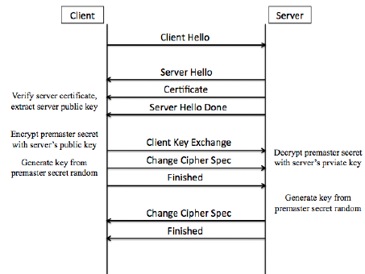

Figure 15: TLS Handhsake betwwen Server and Client [35]

### 3.3.2.2.3: Digital Certificates

Certificates are public keys that are digitally signed either by a Certificate Authority or by the owner of the private key. Those certificates that are signed by the owner of the private key are referred to as "self-signed “. In turns these certificates correspond to a private key.

Steps to get the Certificate [18]:

* The first step to obtaining a certificate is to create a Certificate Signing Request (CSR) file. The OpenSSL command-line interface can be used to generate a CSR for a private key
* Once the CSR file is generated, it can either be sent to a Certificate Authority for signing or used to generate a self-signed certificate.
* Once the certificate is generated, it can be used to generate a .pfx or .p12 file.

The different files that we generated are shown in Figure 16 below.

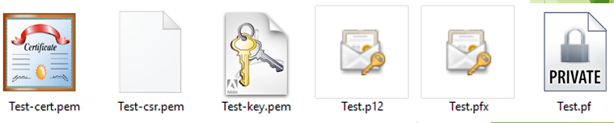

Figure 16: Privacy Enhanced Mail Certificates, Public Key Cryptography Standard #12 file, Personal Information Exchange Certificate and Private File for HTTPS Encryption

### 3.3.2.2.4: The Public/ Private Key

This sections explains a server-client Handshake. As shown in Figure 17 [35], when a client communicates with the server, the client sends the client “Hello’ message which is the beginning of the communication, then the server sends back the certificate which includes the public key that the server has. The public key is already shared to everyone the client uses it to identify the server. Afterwards, the client computes the premaster secret after computing the premaster key it encrypts it using the public key of the server and sends it to the server. The server can then use its private key to then decrypt that encrypted premaster key. Now the server has the premaster secret. Now from the premaster secret the client and the server both generates the master secret and the session key which then leads to bulk encryption. But what happens if the private key is ever compromised either by the hackers or the security agencies. If the hacker can ever get the private key and then what he can do is that he can decrypt the premaster key sent by the client and then he can generate from that premaster secret the actual secret key that is being used in the bulk encryption and can decrypt any information from the secret key. In order to avoid this situation, the perfect forward secrecy comes into play [35].

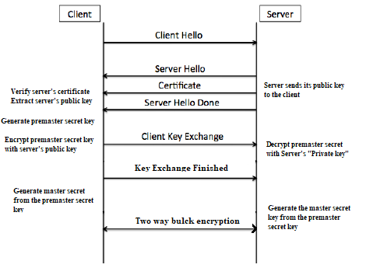

Figure 17: TLS Key Exchanges [35]

### 3.3.2.2.5: Perfect Forward Secrecy

This section explains Perfect Forward Secrecy using Figure 17 [35] below. The steps are the following:

* Client sends the hello message as normal and then what the server’s going to do is that the server then generates a prime number and also the modulo and sends back to the client but also a sit sends back to the client. It never relies on the server or the client using their public or private key in order to exchange the premaster secrets and ultimately the keys.
* Server picks the known prime number and the modulo and then it picks the random integer from this it calculates the value: the value A
* The client will pick its own random integer and using the same prime number and modulo, it calculates its value. It sends that value B back to the server.
* Through the values of A and B they both can generate the premaster secret. So, they both have the pre-master secret and they've got it without using any of their private key. And using this premaster secret, both generate the secret key and then starts communicating. Also, these randomly chosen integers are ephemeral (short lived).
* Brand new random integers are chosen all the time… ephemeral key exchange. And even if someone grab hold of the random integer. Then the communication of that one channel will be compromised but the next time it’s completely different key.

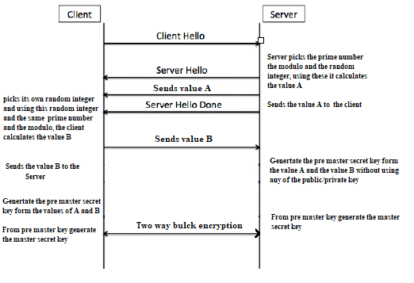

Figure 18: Perfect Forward Secrecy [35]

### 3.3.2.3: Javascript Session Establishment Protocol

The Javascript Session Establishment Protocol Architecture [16] is shown in Figure 19 [34].

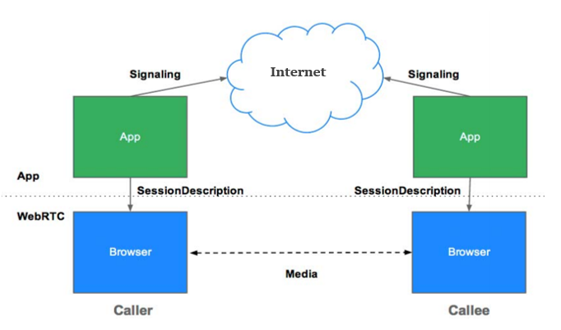

Figure 19: JSEP Architecture [34]

### 3.3.2.4: WebRTC

WebRTC enables real time communication without any plugins. Provided the fact that live communication has been either very complex or expensive to implement, WebRTC provides a more cost effective and simpler mode of RTC (real time communication). Its first implementation was built by Ericsson in May 2011. It now enables video, data and audio communication. The guiding principle of the WebRTC project are its APIs, which by being open source, free, standardized and can be built into browsers and are far more efficient than the existing technologies [34].

### 3.3.2.4.1: Standards and protocols

* The WebRTC W3C Editor's Draft
* W3C Editor's Draft: Media Capture and Streams (aka getUserMedia)
* IETF Working Group Charter
* IETF WebRTC Data Channel Protocol Draft
* IETF JSEP Draft
* IETF proposed standard for ICE
* IETF RTCWEB Working Group Internet-Draft: Web Real-Time Communication

WebRTC is used in various apps such as Facebook, Whatsapp, IOS Browser, appear.in etc.

WebRTC constitutes three APIs; Media Stream, RTC peer connection and RTC Data Channel [34].

### 3.3.2.4.2: WebRTC Support Summary

MediaStream and getUserMedia are supported by Chrome, Opera, Firefox and Microsoft Edge.

RTCPeerConnection is supported by Chrome, Opera and Firefox.

RTCDataChannel is supported by Chrome, Opera and Firefox [22].

### 3.3.2.4.3: WebRTC Applications

WebRTC not only enables the live streaming of audio, video and other data but also enables access to the network information such as IP addresses and port numbers. It is the exchange of this information between with other WebRTC clients is necessary to enable peer connections with them, even through NATs and firewalls. The signaled communication supported by WebRTC enables errors to be reported. Information about media and client capability sucha s codecs and resolution can also be exchanged in WebRTC [29].

The WebRTC Architecture [31] is shown in Figure 20 [34].

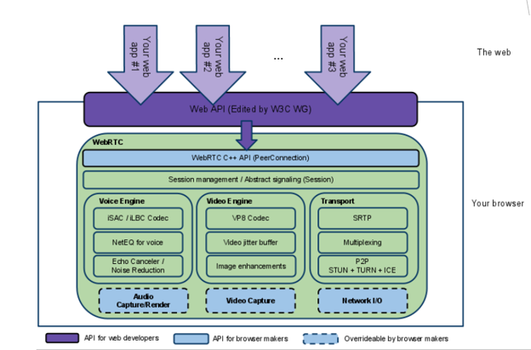

Figure 20: WebRTC Architecture [34]

### 3.3.2.4.4: Media Stream

The API for Media Stream supports synchronized media streams. The input for each Media Stream is generated by navigator.getUserMedia ( ). The output is passed to a video element or an RTC Peer Connection. The getUserMedia ( ) takes three parameters; a constraint object, a success callback and a failure callback. If a success callback is called, it is passed a Media Stream while if a failure callback is called an error object is passed in response. Each Media Stream has a label and these media streams cab retrieved in an array of Media Stream Tracks by using functions getAudioTracks() and getVideoTracks() [17].

### 3.3.2.4.5: RTC Peer Connection

The RTCPeerConnection objects can exchange data and messages directly without having to use any intermediary signaling mechanisms. The caller create a new RTCPeerConnection and adds the stream from getUserMedia (). It then create an offer and sets it as the local description for the pc on which it is operating and as the remote description for the other pc of the callee. In the process it does not use any signaling communication. While the Callee when receives the stream from the caller it displays it as a video element [22].

WebRTC require four types of server-side functionality. These are signaling, NAT/firewall traversal, user discovery and communication and Relay servers. NAT traversal in RTC Peer Connection is achieved through implementing STUN and TURN protocols [28].

### 3.3.2.4.6: Interactive Connectivity Establishment

ICE candidates enable direct communication between the peers through either STUN (Session Traversal Utilities for NAT) or TURN (Traversal Using Relay NAT) Servers. As these enable access to the network information of peers behind NAT or firewalls. STUN servers are used initiallt fir RTC Peer connection if these fail then Relay servers are used instead [28].

The Interactive Connectivity Establishment framework is shown in Figure 21 [34].

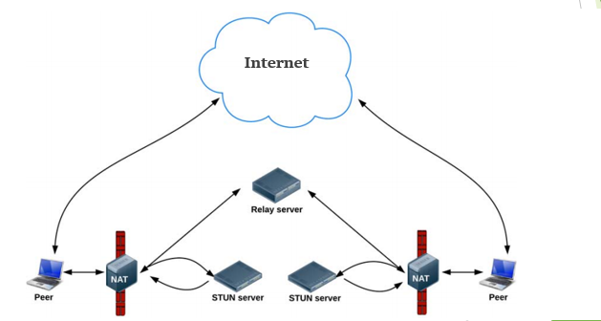

Figure 21: Framework for finding ICE Candidates [34]

### 3.3.2.4.7: RTC Data Channel

The RTCDataChannel API enables peer-to-peer exchange of arbitrary data, with low latency and high throughput. There are many potential use cases for the API, including: gaming, remote desktop application, Real-time text chat, file transfer and decentralized networks. The API has the following features: leveraging of RTCPeerConnection session setup, multiple simultaneous channels with prioritization, Reliable and unreliable delivery semantics, Built-in security (DTLS) and congestion control and the Ability to use with or without audio or video. Communication occurs directly between browsers, so RTCDataChannel can be much faster than WebSocket [22].

### 3.3.2.4.8: Signaling

WebRTC uses RTCPeerConnection to communicate streaming data between browsers, but also needs a mechanism to coordinate communication and to send control messages, a process known as signaling.Signaling is not part of the RTCPeerConnection. Signaling is used to exchange three types of information. Session control messages for initializing or closing communication and reporting error. Network configuration that is the IP address and port .Media capabilities, these include codecs and resolutions [29].

### 3.3.2.5: Global Functionality of Call Center

The Call Initiation Chain is shown in Figure 22 [34]. Initially upon request the users receive their respective pages. The caller then calls the getUserMedia () function [20] too get its stream which it saves as its local and starts a new peer connection object using this stream. The caller presses the call button and calls the createOffer () function of the peer connection. The call back of this function is set as local description [24] and is emitted to the agent who, similarly, on the other end has saved its local stream by calling the getUserMedia () [20]. The agent recieves the offer, saves it as its remote description and using this offer creates an answer and sends it over to the caller. The caller recieves this answer and saves it as its remote description [24]. The caller selects an ice candidate [27] from the arrived list of available candidates to its PC and sends it over the socket channel using socket.on () [26]. The agent sets the candidate and sends over its ice candidate using socket.emit () [26]. The remote streams are exchanged when a RTC PeerConnection communication channel is established [22].

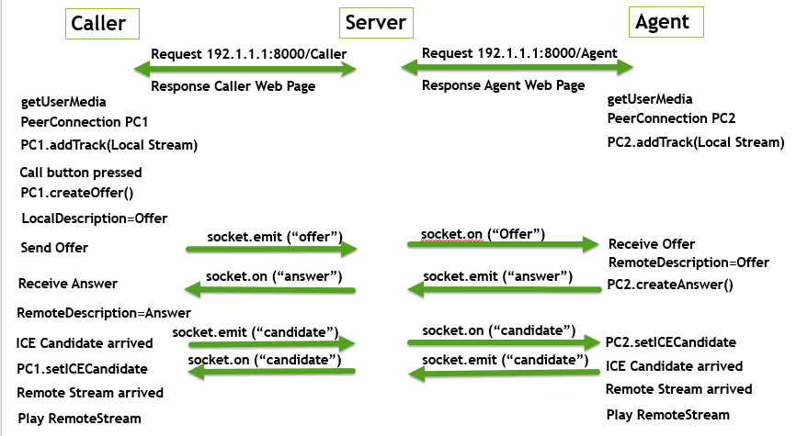

Figure 22: Call Initiation Chain [34]

### 3.3.2.6: Server Code

We made a mediator server using Nodejs which connected the caller-agent peer and handled their respective communication.

We required various modules to implement our server [19]. We used namely:

* fs: for handling file system transfer between CallCentre, Caller and agent html page.
* http: to make Node.js act as HTTP server, similarly https for secured connectivity.
* socket.io: this module was used for real time event-based communication (request, response between caller and agent) [26].
* os: this provides several operating system-related utility methods.

We handled number of callers and agents by having separate socket arrays so that upon availability and skill matching, a pair can be made of the caller and the agent candidate. As we are using socket library for real-time communication, we used its following events

* Type: user defines if it wants to be agent/caller.
* ICECandidate: sends ICE candidate [27].
* Offer: sends Session Description Protocol SDP [24].
* TextMessage: sends and receives text messages.
* Answer: answer SDP to caller offer.
* FileInformation: sends file information from caller and sends to agent.
* Disconnect: fired when client (caller/agent) disconnects, count added to Drop variable

### 3.3.2.7: Call Center Home Web Page

This Call center Home web page is shown in Figure 23 which can be accessed using <https://10.103.76.173:8000/>

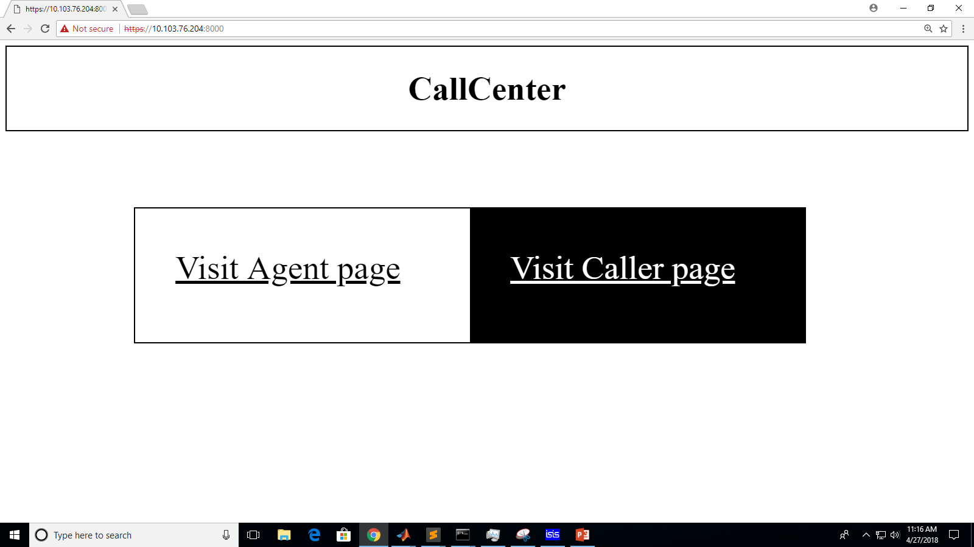

Figure 23: Call Center Home Web Page

The user then opts to become a caller, or an agent and they are then forwarded to their respective pages as below :

### 3.3.2.8: Caller Web Page

The Caller Web Page is shown in Figure 24. It has dedicated blocks showing local and remote audio streams, and a Fourier visualizer. Caller can send and receive text and files, choose the skill, bandwidth, codec, call and hang-up.

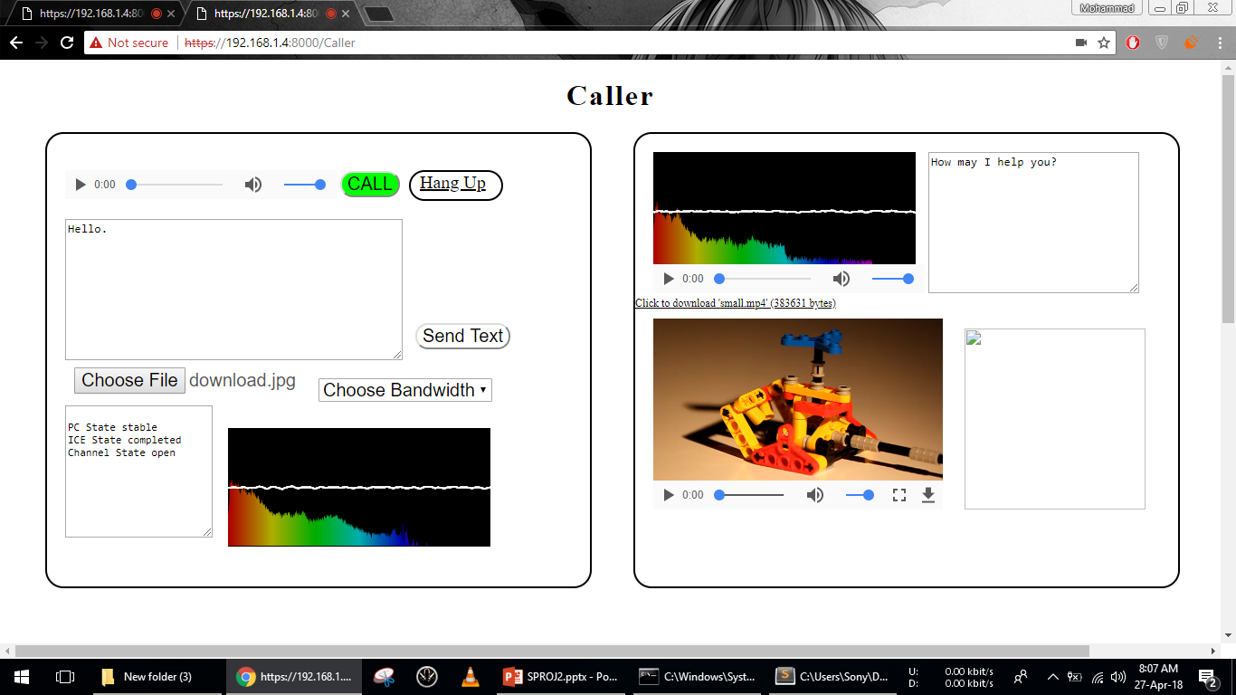

Figure 24: Caller Web Page

### 3.3.2.9: Agent Web Page

The Agent Web Page is shown in Figure 25. It has dedicated blocks showing local and remote audio streams, and a Fourier visualizer and available functions area. Agent can send, receive text and files, choose the skill, call and hang-up.

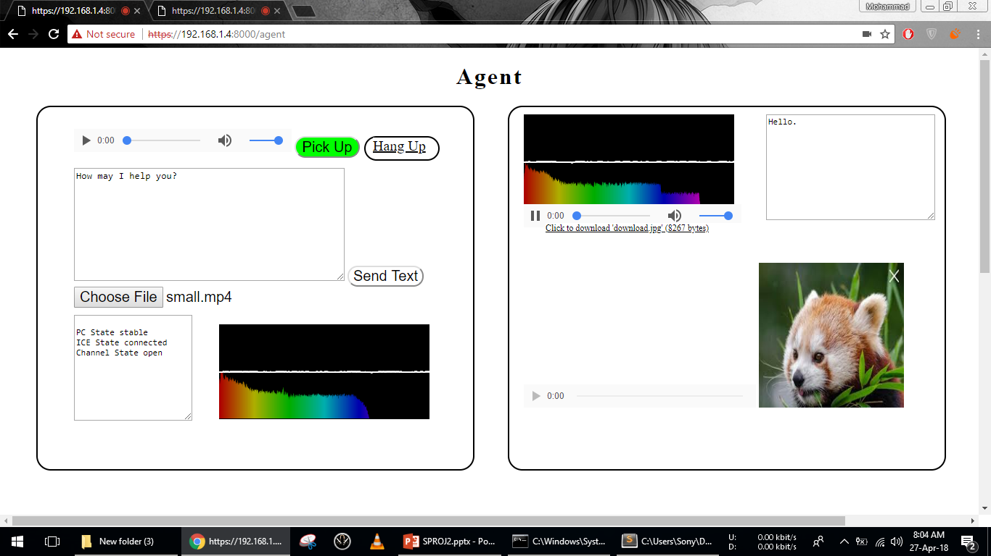

Figure 25: Agent Web Page

### 3.3.2.10: Additional Features

We added several additional features to our system, namely : a log file for call records, calculating performance metrics at server, the functionality to change bandwidth on the fly and the funcionality that the caller can specify upon which bandwidth it can communicate (125bps, 250bps, 500bps, 1000bps or Unlimited Bandwidth.).

Another flexibility is in choosing Audio Codec from a given the list : (iLBC (Default), iSAC 16K, Opus, G722, PCMU). Both pages have a stream visualizer showing Fourier Transform of local and remote Audio Signal. We also enabled group calls through making and managing multiple RTC PeerConnections at the same time.

# **Chapter 4**

### **Design, simulation and implementation results**

In this chapter, we will be presenting the results obtained so far during the course of this senior project both from simulation and implementation perspectives as the final report (thesis) should be self-contained.

### **4.1: Finalized System Model: Real Call Center**

In order to better understand the real call center, we received the data from materials of a course entitled Service Engineering, taught by Professor Avishai Mandelbaum at the Technion, Israel [9]. The records are shown in Figure 26. It emphasized, theoretically, on Queuing Theory, and, practically, on Telephone Call Centers and Service Networks. We extracted a one-day data, sorted its respected fields, and based our simulations upon them. This worked as both a limitation, in terms of more close approximation, and an extension, to match theoretical results for our proposed model to that of theoretical models.

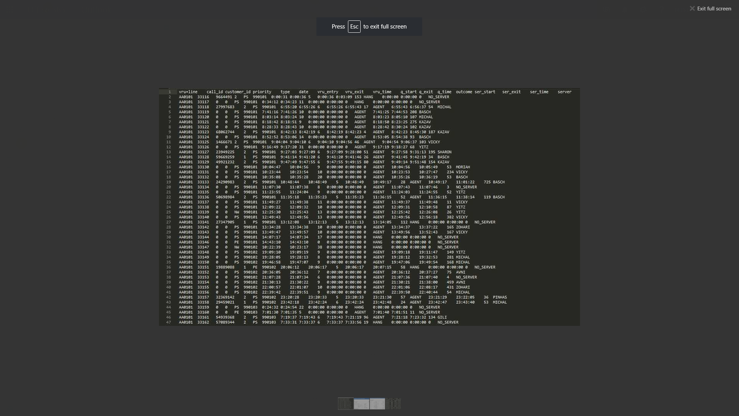

Figure 26: Call Center Records

Next, we present the strategy used to extract meaningful information from the obtained call center records in factors influencing the choice of final design section.

### **4.2: Factors Influencing the Choice of Final Design**

Our initial model was closer to the ideal situation in which the calls arrival follows the Poisson distribution with the fixed arrival rate. However, in case of real call center, the arrival rate is not fixed but it varies with time and also follows a distribution. To make our model more realistic we also added the Virtual Response Unit (VRU) functionality. Also, the calls were routed according to the single routing scheme, which was skill based routing, irrespective of the calls arrival rate, server’s experience, call serving speed etc. which resulted in the average performance. In order to increase the performance and to reduce the queue waiting time we devised four different routing schemes, which are: Fastest Server First Routing (FSF), Longest Idle First routing (LIF), Lowest cost first Routing (LCR) and the Skill based routing (SBR). We utilized these routing schemes according to the changing call arrival rate with respect to time.

Moreover, in the results of our initial model, the mean waiting time found from the simulation was deviating from that of the real call center for lesser number of agents, though the results were quite similar for the larger number of agents. Thus, in order to match the results with the real call center, we did the data analysis on the real call center data and found the distributions for each variable like average call time, probability of waiting in the queue, traffic intensity, agent’s service level, agent’s salary etc. and used these variables for implementing various routing schemes.

In the real call center Arrival, rates are different at different times of day. Hence, we must change the average arrival rate of calls each hour. Callers must specify their required skill using Virtual Response Unit VRU; Callers can abandon Queue after waiting for some time and hang up at any time. The calls are routed based on their required skill. The Agents have inhomogeneous service time distributions and up to six skills. There are 23 agents available in the call center. Their scheduled are dynamic i.e. more agents are called to handle calls when traffic is high. Each Agents has an average call service time of three hours and answers around 75 calls each day. As in Erlang X, Specialists have only one skill and Generalists can have two or more skills. Agents are scheduled depending on Traffic Intensity.

We used the call center data to extract information about agents and callers. First, we used all the calls to extract the Call Durations Distribution. The same distribution can be generated in NS3 using a Random Variable Generator. There were a lot of call drops and call abandonments with a call duration of zero seconds. They were used to estimate the average patience of caller in the queue. The data revealed that the Agents were scheduled dynamically based on the arriving Call traffic. The Queue Waiting Times Distribution revealed that Queue waiting time was higher when call traffic was higher. We also used the Virtual Response Unit Times Distribution to estimate how much time the average caller spends in the VRU. The Distributions were input into the simulator to simulate what happened in the real call center on a particular day.

The Extracted Distributions of Call Durations are given in Figure 27.



Figure 27: Distribution of Call Durations

The Extracted Distributions of Queue Waiting Times are given in Figure 28.



Figure 28: Distribution of Queue Waiting Times

The Extracted Distributions of VRU Durations are given in Figure 29.



Figure 29: Distribution of VRU Durations

The Extracted Profiles of Agents are given in Table 1.

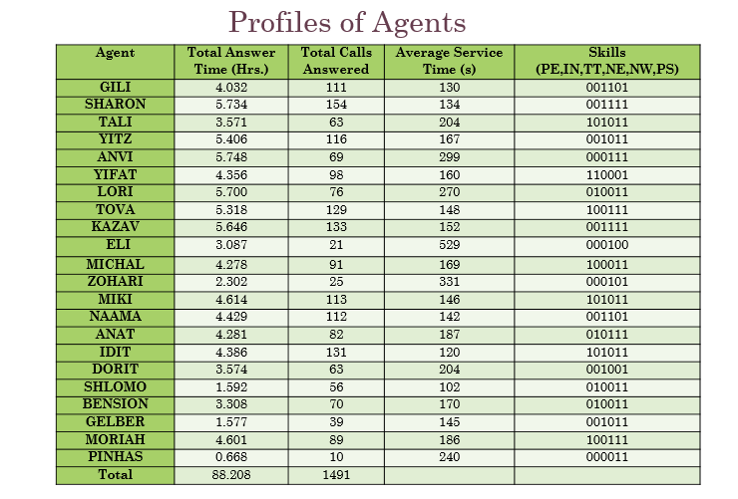

Table 1: Profiles of Agents

### **4.3: Final System Diagram**

In our final design, the calls arrive according to the Poisson distribution with the variable arrival rate, which keeps, on changing with time. There is also the virtual response queue in which all the calls wait for some time specifying their requirements. The agent nodes are characterized based on their exhaustion level, efficiency level, training level, age, experience, leaves, breaks, schedules, speed, and learning, Calls Serviced, Mean Service Time, and Quitting Probability. Where the distribution of all such variables are drawn from the real call center data. In the final design, the basic routing was done based on the agent’s skills and the caller’s requirements. However, according to the variable arrival rate, dynamic routing was utilized. FSF was used when the calls arrival rate was higher so that more calls could be served and the calls drop rate would be small. In case of moderate arrival, rate lowest cost first routing was used to optimize the cost of running the call center. LIF was used when the arrival rate was small so that the non-experienced agents could gain experience by handling more calls. Upon Arrival, the Caller must enter the Virtual Response Unit Linked List where it is assigned a VRU Counter that decrements every second. When the VRU Counter hits zero, the Caller enters the Callers Queue if Agent with the required skill is busy. When the Agent becomes idle, the packet is routed to him. His job is to service the packet for a random period dictated by a random distribution with a mean value depending on the Agent’s Experience. The Agents are paid on hourly basis and their scheduling is done based on the hourly traffic intensity. The Call Centre is shown in Figure 29, the Virtual Response Unit is shown in Figure 30 and the Queue is shown in Figure 31.

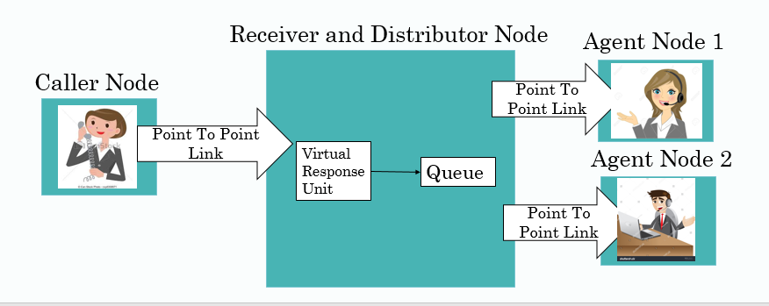

Figure 30: Call Center Block Diagram

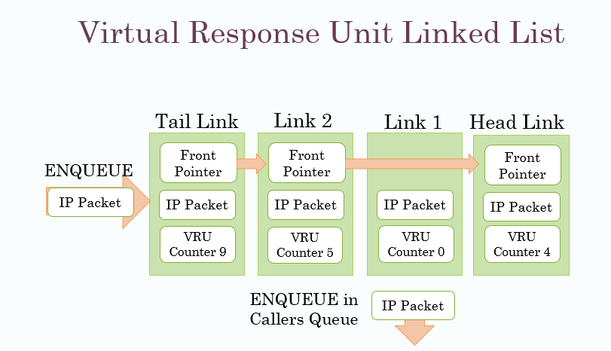

Figure 31: Virtual Response Unit Linked List

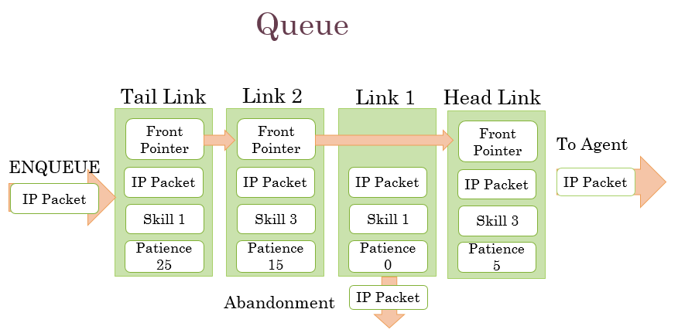

Figure 32: Callers Queue Linked List

**4.4: Simulation Methodology**

The technique that we used was that using the Agent profiles extracted earlier, we programmed the agents to have similar properties as the real agents. Then we generated traffic similar to the actual traffic and kept a log of all the calls in the simulation including: Packet Size, skill, VRU Time, Patience, Id, EnqueueTime, Dequeue Time, Drop Time, Abandonment Time, Agent Id, Agent Wage, Service Time and used this data to calculate important performance metrics of the call center and to compare results with real data.

We made a primary Virtual Response Unit Linked List that comes before Callers Queue. For that, we added a Virtual Response Unit counter in each Link. We decrement Virtual Response Unit Counter of each Link after every second and if Virtual Response Unit Timer hits zero, we remove the Link from Virtual Response Unit Queue and Enqueue in Callers Queue. Before Enqueue, we check if queue is full. If queue is full, packet is dropped.

//Whenever a packet is received at receiver node, we Enqueue it in VRU Queue. Each Link has a Packet Pointer, VRU Timer, EnqueueTime, Front and Back Link Pointers.

void VRUEnqueue (Ptr<Packet> packet, uint32_t VRUTime)

{…

Link* p =new Link;

p->VRUtime =VRUTime;

p->pkt =packet;

p->EnqueueTime =Time (Seconds (Simulator: Now (). Get Seconds ()));

Link * t =Tail->Front;

Tail->Front =p;

p->Front =t;

t->Back =p;

p->Back =Tail;

NumberOfPacketsInQueue ++;

Total Packets ++;

}

//This Function is called every second. It decrements the VRU counter of each Link in VRU Queue. If the timer of any Link is zero, the packet in that link is removed and we Enqueue it in Caller’s Queue.

void VRUCountDown (Distributor Queue * queue)

{…

if (NumberOfPacketsInQueue>0)

{

Link* a =Head;

while (a! =Tail)

{

a =a->Back;

a ->VRUtime= ((a->VRUtime)-1);

if (a->VRUtime==0)

{

Link* b =a->Back;

Link* c =a->Front;

b->Front =c;

c->Back =b;

NumberOfPacketsInQueue--;

queue->Enqueue (a->pkt);

}

}

}

}

Each Agent has his own distribution of service times and skills.

//SocketRecv is called whenever Agent Receives a Packet for service. This Function generates a random number for Operator Efficiency. Service time duration is average of Packet Size and Operator Efficiency. Agent remains busy for that duration and calls ServiceComplete function after that time to become idle again.

void SocketRecv (Ptr<Socket> socket)

{…

MyPacket =MySocket->Recv ();

PacketSize =MyPacket->GetSize ();

OP_Efficiency = EfficiencyGenerator->GetInteger ();

Servicing [AgentNumber] =1;

Time tnext (Seconds (static_cast<double> ((PacketSize+OP_Efficiency)/2)));

SendEvent =Simulator: Schedule (tnext, &AgentApp: ServiceComplete, this);

}

void ServiceComplete ()

{…

idleArray [AgentNumber] =1;

Servicing [AgentNumber] =0;

Packets Served ++;

MySocket ->SetRecvCallback (MakeCallback (&AgentApp: SocketRecv, this));

Total Wages+=WagePerCall;

}

A Caller Node keeps generating IP packets and sends them to the distributor node using a Point-to-Point Link. The Packet length follows a fixed distribution and has a fixed mean value. The Call Skill is denoted by a random variable and is stored in the TOS Tag of the IP Packet. The Caller Patience random variable is stored in the TTL Tag of the IP Packet. This is implemented in NS3 by a function that generates a random variable for Call length, Call Skill and Caller Patience, makes an IP packet of that size, adds the IP Tags and then sends it using a socket. The function then makes a self-call by scheduling the next call after a time interval given by a random number following a negative exponential distribution.

The Distributor Node receives the IP packets and keeps adding them to the tail of the VRU Linked List along with a VRU Timer Number, which is decremented every second. Once VRU counter becomes zero, packet is Enqueued in Callers Queue if the Queue is not completely full. If Queue is full, call is dropped. Caller can either redial or else call is lost. It also checks every second if any Agents are idle and distributes the Packets from the Queue to them. It traverses the entire Queue and checks if the idle Agents have the skill required by the Packet. In NS3, it schedules a call to SendPacket function every second, which does the routing of calls using Point to Point Links to Agents with required skill.

The Agent Node receive the IP packet from the Distributor Node and becomes busy for the duration of the call. Hence, it changes the Boolean idle flag to zero. It schedules a call to ServiceComplete function after a period equal to the length of the call after which it changes its status to idle again. Agents are scheduled and leave service based on schedules.

Now we present the Caller, Distributor and Agent Node Applications designed for this Final Call Center Model framework.

### 4.4.1: Caller Node Application

The Caller Agent Node Application is shown in Figure 33.

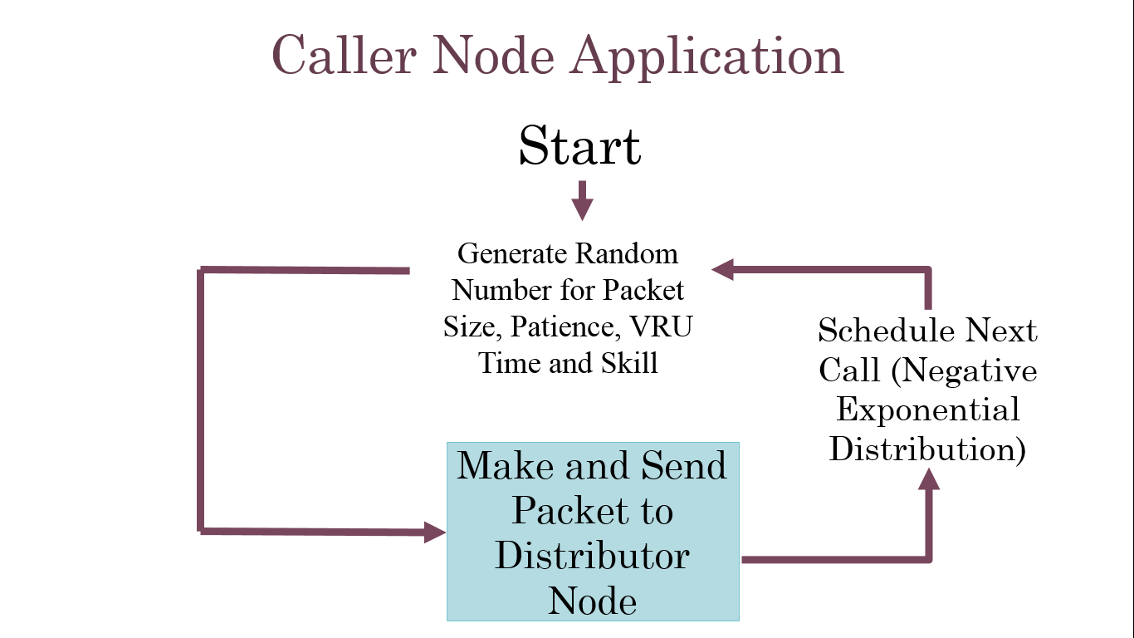

Figure 33: Caller Node Application

void SendPacket ()

{…

Size =PacketSizeGenerator ->GetInteger ();

Waitingtime =WaitingTimeGenerator ->GetInteger ();

Skill =SkillTypeGenerator ->GetInteger ();

Time =InterArrivalTimeGenerator ->GetInteger (); //Generate Random Numbers

Socket->SetIpTos (skill); //Set Packet Skill Tag

Socket->SetIpTtl (waitingtime); //Set Packet Waiting Time Tag

Ptr<Packet> packet=Create<Packet> (size); //Make Packet

Socket->Send (packet); //Send Packet

Time tnext (Seconds (static_cast<double> (time))); //Schedule self-call

SendEvent=Simulator: Schedule (tnext, &CallerApp: SendPacket, this);

}

### 4.4.2: Distributor Node Application

The Distributor Node Application is shown in Figure 34.

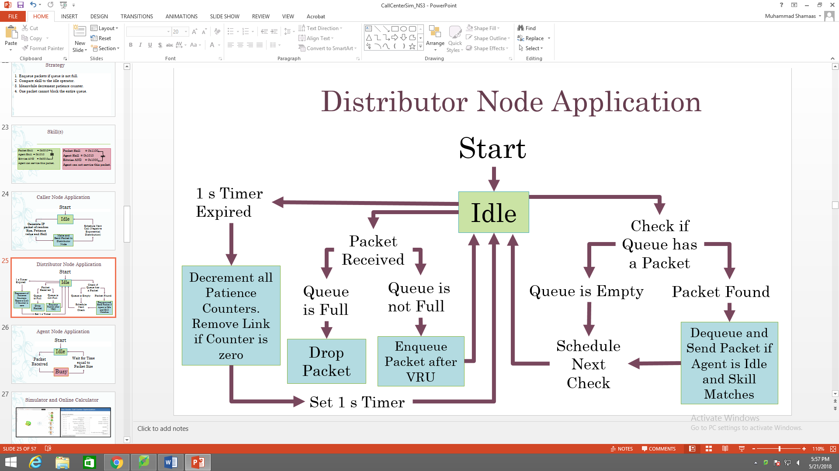

Figure 34: Distributor Node Application

void SkillBasedRouting ()

{…

If (idle [PeerNumber] && (queue->NumberOfPacketsInQueue>0)) //Checks

{ DistributorQueue::Link* a=queue->Head->Back;

If ((SkillArray [PeerNumber] & a->Skill)>0) //Match Skill

MySocket ->Send (a->Packet); //Send Packet

Time tnext (Seconds (1)); //Schedule self-call

SendEvent =Simulator::Schedule (tnext, &DistributorApp: SkillBasedRouting, this);

}

}

void SocketRecv (Ptr<Socket> socket)

{…Address from;

Ptr<Packet> packet=MySocket->RecvFrom (from); //Receive Packet

Queue->Enqueue (packet); //Enqueue Packet

MySocket->SetRecvCallback (MakeCallback (&ReceiverApp: SocketRecv, this));

}

### 4.4.3: Agent Node Application

The Agent Node Application is shown in Figure 35.

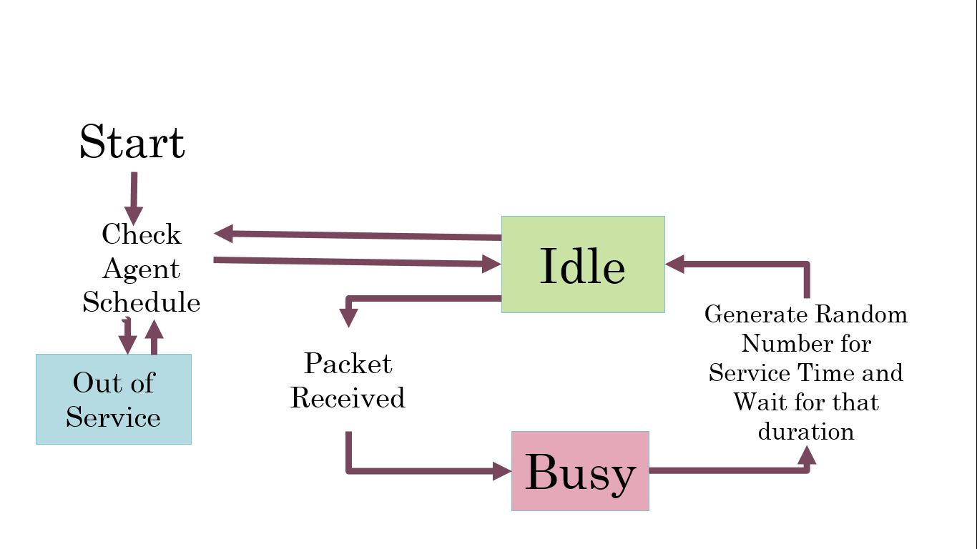

Figure 35: Agent Node Application

void SocketRecv (Ptr<Socket> socket)

{…

MyPacket =MySocket->Recv (); //Receive Packet

PacketSize =MyPacket->GetSize ();

OP_Efficiency = EfficiencyGenerator->GetInteger (); //Generate random number for service time

Time tnext (Seconds (static_cast<double> ((PacketSize+OP_Efficiency)/2)));

SendEvent =Simulator: Schedule (tnext, &AgentApp: ServiceComplete, this);//Schedule call to ServiceComplete Function after Service Time is over

IdleArray [AgentNumber] =0; //Busy

}

void ServiceComplete ()

{… IdleArray [AgentNumber] =1; //Idle

MySocket ->SetRecvCallback (MakeCallback (&AgentApp: SocketRecv, this));

//Call SocketRecv Function when call arrives

}

### **4.5: DesignResults**

### **4.5.1: Erlang C Block Diagram**

The model for simple Erlang C Queue is shown in Figure 36.

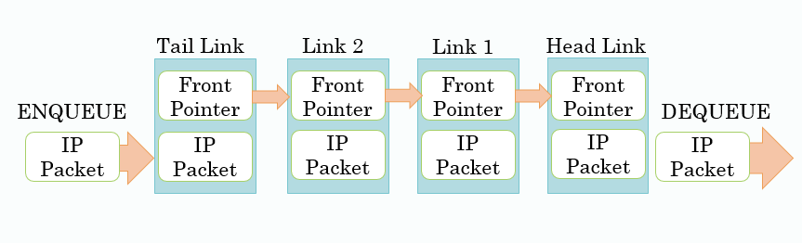

Figure 36: Erlang C Queue

### **4.5.2: Erlang X Block Diagram**

The model for improved Erlang X Queue is shown in Figure 37.

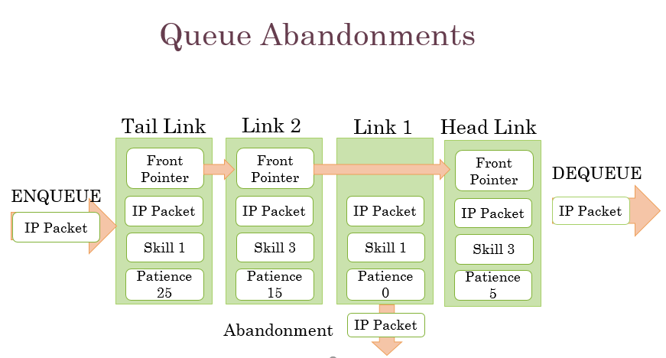

Figure 37: Erlang X Queue with Abandonments

### **4.5.3: Real Call Center Block Diagram**

The model for Real Call Center VRU Queue and Callers Queue is shown in Figure 39 and 40.



Figure 38: Real Call Center Block Diagram



Figure 39: Virtual Response Unit Linked List



Figure 40: Real Call Center Queue

### **4.6: Simulation Results**

### 4.6.1: Erlang C

After having discussed the Caller, Distributor and Agent Node Applications, now we will discuss the simulation results and compare them with Erlang C Calculator [2]. The Simulation technique was that we generated 10000 calls and calculated the mean queue waiting time for that run. Then we repeated these 10 times to obtain a 90% confidence interval and mean of distribution for a particular number of agents. The results are given in Table 2. We plotted the simulation results against Erlang C Calculator results [2] as shown in Figure 41.

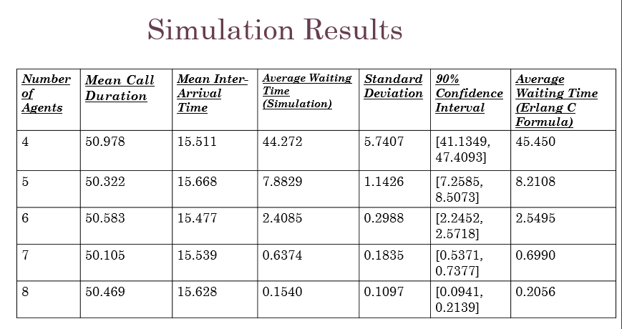 Table 2: Erlang C Simulation and Calculator Results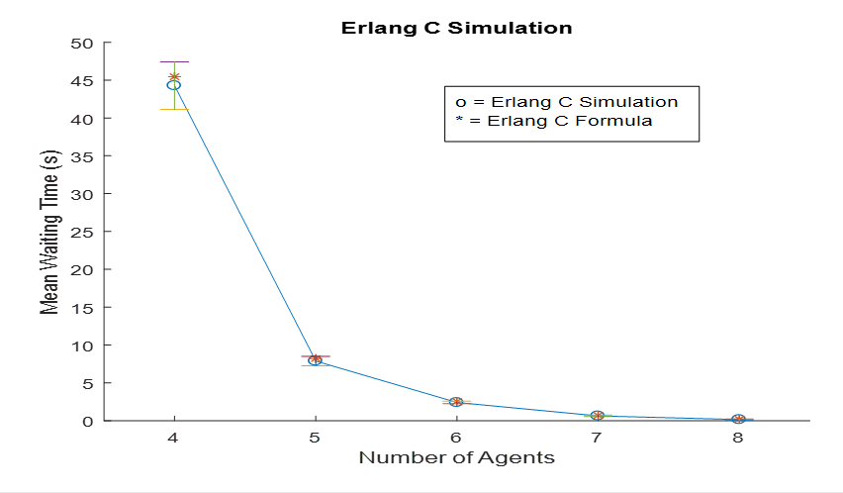

Figure 41: Erlang C Simulation and Calculator Graph

### 4.6.2: Erlang X

Our Simulation technique was that we generated 10000 calls and calculated the mean queue waiting time for that run. Then we repeated 10 times to obtain a 90% confidence interval and mean of distribution for a particular number of agents. We plotted the simulation results against Erlang X Calculator results [3] as shown in Table 3 and Figure 42.

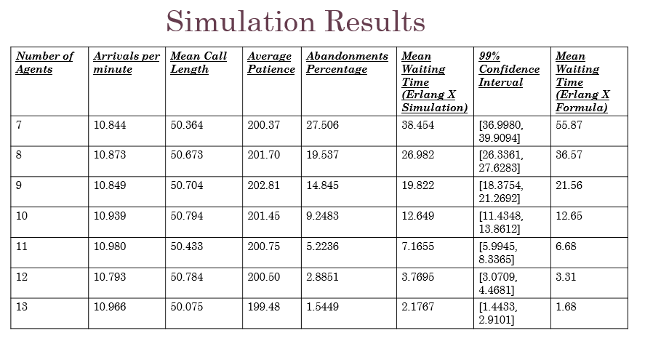

Table : Erlang X Simulation and Calculator Results

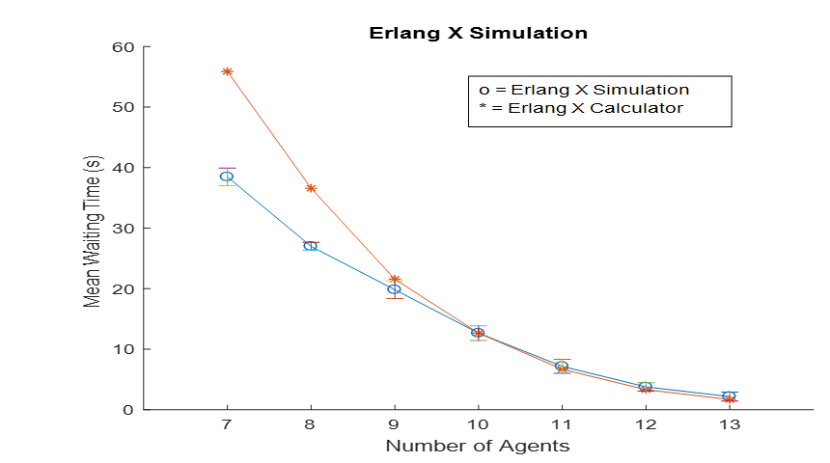

Figure 42: Erlang X Simulation and Calculator Graphs

### 4.6.3: Real Call Center

This section discusses the results of Real Call Center Simulation. The technique used was that we generated call traffic similar to real Call Center as studied using Call Center Records [9] and calculated the mean queue waiting time for each hour. Then we repeated these 10 times to obtain a 90% confidence interval and mean of distribution for a particular hour. We plotted the results against Real Call Center results. The Caller Traffic is shown in Figure 43. The Mean Queue Waiting Times for Simulation and Real Call Center are shown in Figure 44.



Figure 43: Number of Arivals per Hour



Figure 44: Average Queue Waiting Time: Actual Data vs Simulation Results

Two Sample Simulator Runs are shown in Figures 45 and 46.



Figure 45: Average Queue Waiting Time: Actual Data vs Simulated Results



Figure 46: Average Wait Time: Actual Data vs Simulated Results

We studied the real call center records for 1 year which had almost 300000 calls in 354 days. By analyzing every day, we plotted the abandonments vs Number of Agents available in an hour and Number of Calls arriving in the hour as shown in Figure 47. As the number of Agent available increases, the abandonments decrease. When the Number of Calls arriving per hour increase, the abandonments increase.

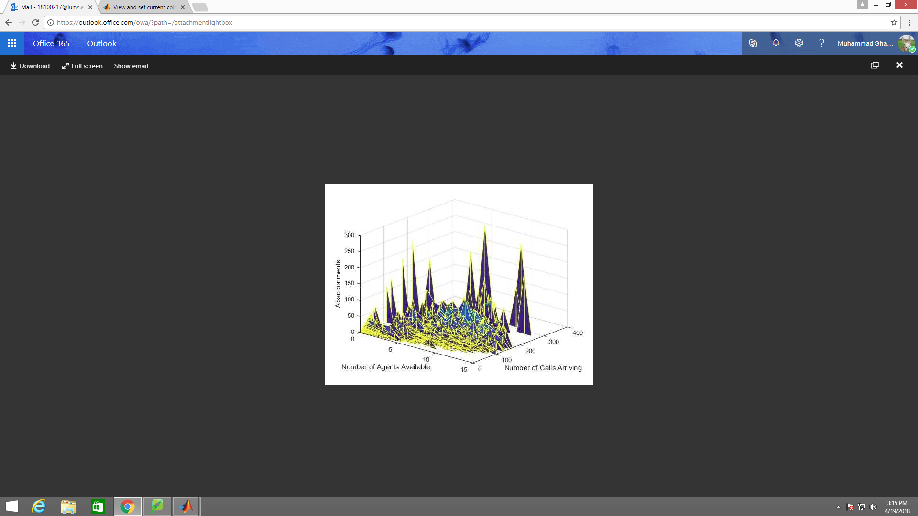

Figure 47: Real Call Center: Abandonment vs Agents Available and Number of Calls Arriving per Hour for 1 year

Then we simulated 1 year of calls in NS-3 with same conditions as in the real call center. The controlled variables included: Scheduling of Agents, Call Traffic, Call Duration Distribution, VRU Duration Distribution, Agent Profiles and Caller Patience Distribution. By analyzing every day, we plotted the abandonments vs Number of Agents available in an hour and Number of Calls arriving in the hour as shown in Figure 48.

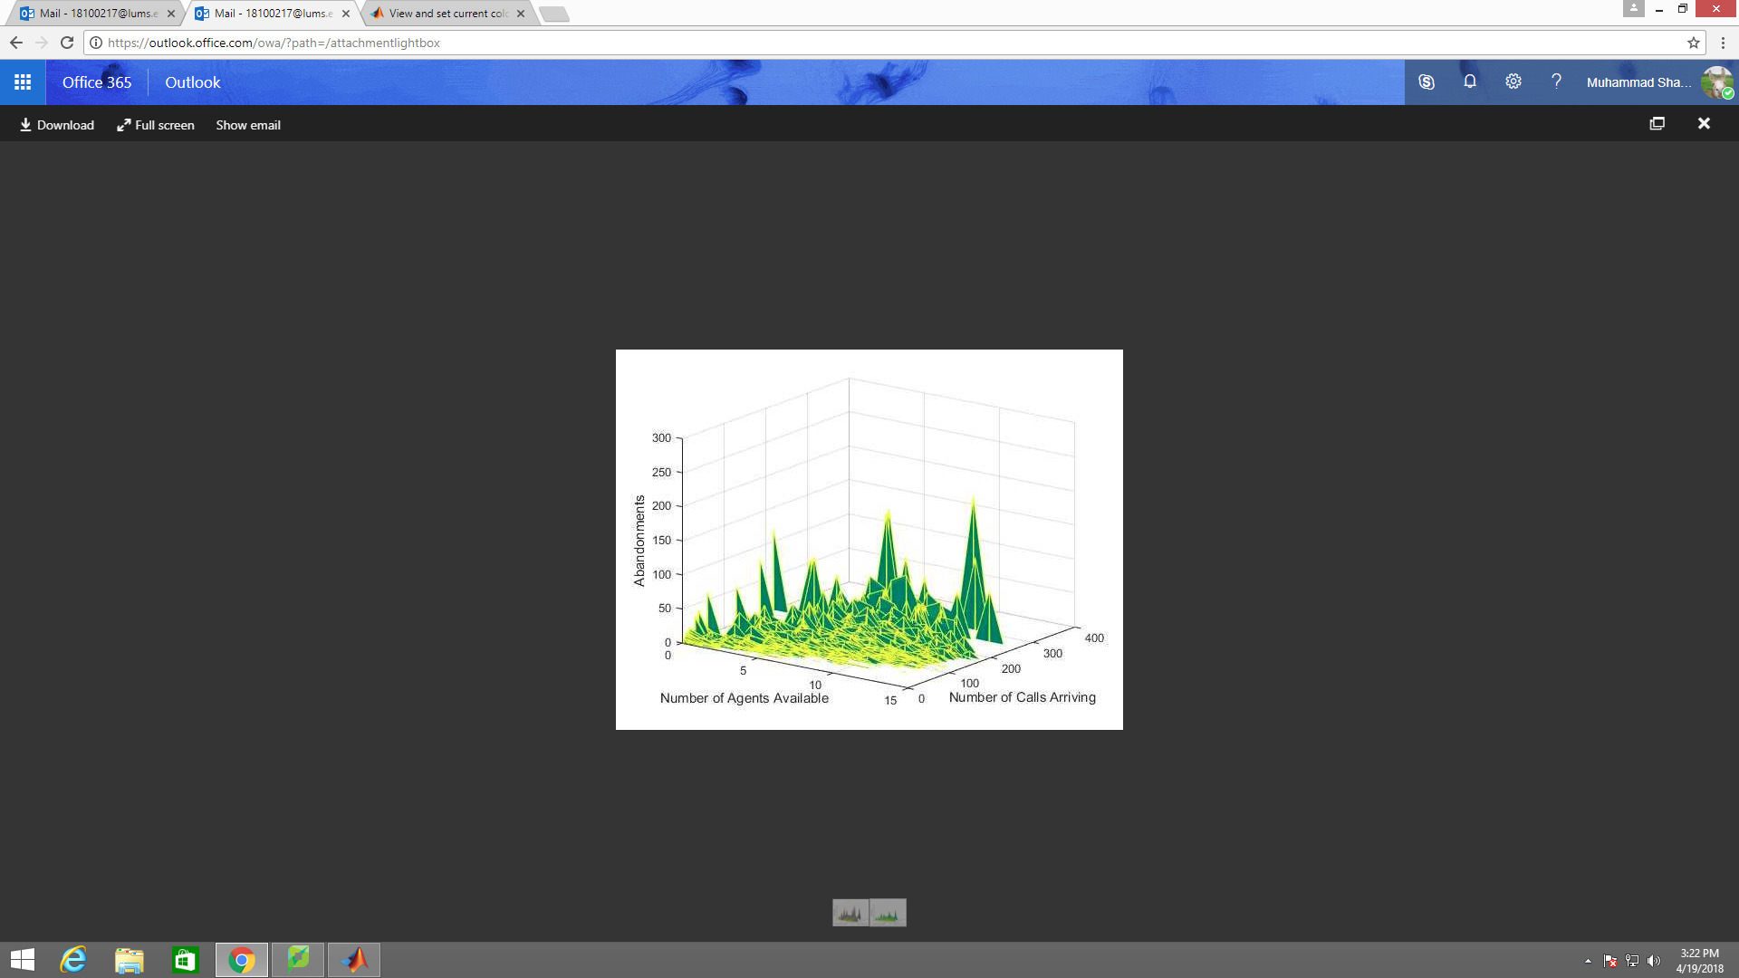

Figure 48: Real Call Center Simulation with Skill Based Routing: Abandonment vs Agents Available and Number of Calls Arriving per Hour for 1 year

In order to compare the performance of NS-3 Simulator with the real Call Center, we calculated the Pearson’s Correlation Coefficient for the two distributions.  Pearson’s Correlation Coefficient is defined as the covariance between two random variables divided by the product of the standard deviations of the random variables. Hence it measures linear dependence between two variables. The Pearson product-moment correlation coefficient will always be between -1 and 1. The closer the value is to either -1 or 1 the more highly correlated the two variables. A correlation coefficient equal to either -1 or 1 indicates a perfect linear relationship between the two variables. A correlation coefficient close to 0 simply indicates that the two variables are not linearly related, however they still may be highly correlated in a nonlinear sense. Hence there is a great disadvantage of using Pearson’s Correlation Coefficient.

Pearson’s Correlation Coefficient = $\frac{N\sum{XY}-(\sum{X})(\sum{Y})}{\sqrt{\left[N \sum{\left(X^{2}\right)-(\sum{X})^2}\right]\left[N \sum{\left(Y^{2}\right)-(\sum{Y})^2}\right]}}$ = 0.917

The Pearson Correlation Coefficient is very close to 1 hence the results are highly positively correlated as evident from Figure 49. Besides Abandonments and Mean Waiting Time, other important performance metrics were also calculated which will be presented in the next section.



Figure 49: Correlation between Real Call Center and NS-3 Simulation

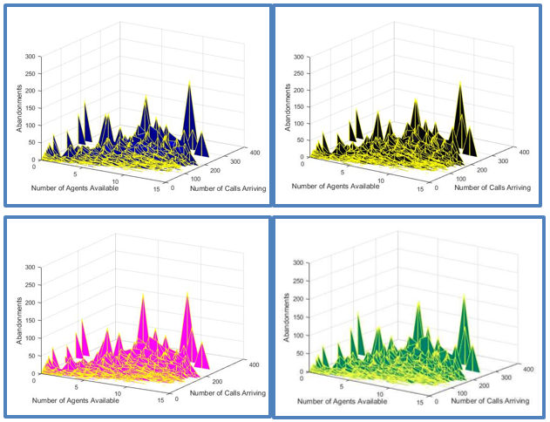

Figure 50: Comparison of Routing Schemes: Fastest Server First (Upper Left), Longest Idle First (Upper Right), Lowest Cost Routing (Lower Left), Skill Based Routing (Lower Right)

### 4.6.4: Data Analysis

In addition to the Observations taken above, we kept a log of all the calls in the simulation including: Packet Size, skill, VRU Time, Patience, Id, EnqueueTime, Dequeue Time, Drop Time, Abandonment Time, Agent Id, Agent Wage, Service Time and used this data to calculate important performance metrics of the call center:

1. **Service level of the call**: it is the percentage of calls answered in less than specific time limit.
2. **Total Problem Resolution**: This was found by calculating the number calls resolved initially to those of the incoming calls that is the percentage of calls resolved in the first attempt.
3. **Agent Salaries** (hourly basis) depending on their performance
4. **Net Promoter Score**: this was calculated in response to every call, so was used to determine the performance of our call center system overall. Under this system every call received resulted in an increment in the NPS  by 10, if dropped contributed nothing to it, if abandoned resulted in an increment by 10 and if was answered the NPS was further incremented by 10.​
5. **Quality Scores**: these were agent rating done by analyzing and calculating the speed of answer of each agent and also the frequency of calls a specific agent answers in a given period of time.
6. **Profits**: this was calculated by finding the ratio of the calls received in a given interval of time to the agent’s hourly salary.
7. **Agents utilization** (percentage of time the agents are busy)
8. **Average Caller Time in System** : sum of the queuing delay and the call time for each call.
9. **Probability of wait** : this was calculated by considering the arrival of calls when queue is not empty.
10. **Traffic Intensity** (Arrival rate / Service Rate)

The Calculated Performance metrics for a sample run are shown in Table 4.

|  |  |
| --- | --- |
| **Performance Metric** | **Value** |
| Arrivals Per Minute | 1.038 |
| Mean Packet Size | 169.577s |
| Blocking Percentage | 0% |
| Average Patience | 785s |
| Abandonments Percentage | 0.268276% |
| Mean Waiting Time | 0.131809s |
| Call Resolution | 1487/1489 |
| Net Promoter Score | 71.8521 |
| Agents Utilization | 15.343% |
| First Call Resolution | 100% |
| Average Time in System | 174s |
| Total Wages | Rs.37489 |
| Quality Scores | 1483 |
| Waiting Probability | 0.402414% |
| Service Level | 99% |
| Traffic Intensity | 2.9337 |

Table 4: Real Call Center Simulation: Calculated Performance Metrics

We verified the call center model and we could guage the different performance metrics, so we attempted to improve the performance by using four different routing schemes.

### 4.6.5: Various Routing Schemes

1. Fastest Server First (FSF): calls are routed to the idle agents having high speed.
2. Longest Idle First (LIF): calls are routed to the agents who are idle for longest time.
3. Lowest Cost Routing (LCR): calls are routed to the idle agents having lowest wage.
4. Skill Based Routing (SBR): calls are routed to the idle agents having required skills.

The schemes are compared in Table 5 and the results are plotted in Figure 51.

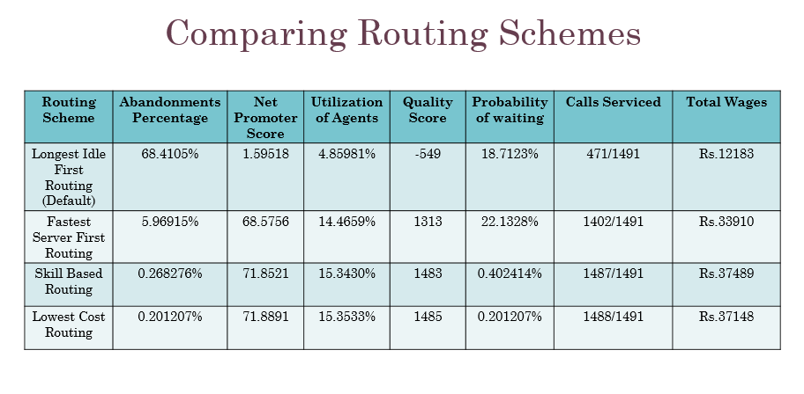

Table 5: Comparison of Routing Schemes

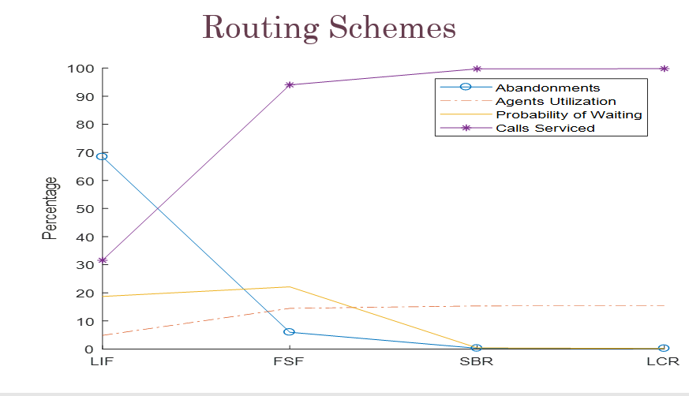

Figure 51: Comparison of Routing Schemes

### **4.7: Implementation Results**

### 4.7.1: Node.js Call Center

The Node.js Call Center implementation differs from the NS-3 Call Center simulation because the network performance degrades in a non-linear manner as the number of Callers in the system increases but the Simulator does not model this effect. By varying the numbers of Active Callers in the System, we were able to determine the degradation in the Quality of Service of the network. Figure 52 shows that the time taken to send a 5 MB file increases greatly as the number of active Agent-Caller Peers increases from 2 (970 ms) to 8 (2890 ms). The internet speed is also variable and data transmission is sporadic.

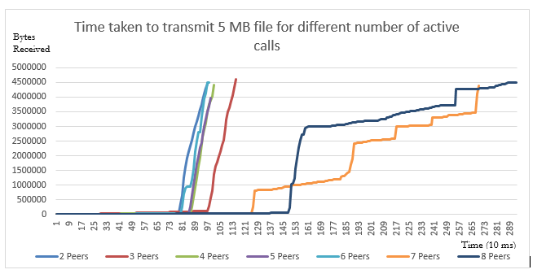

Figure 52: Degradation of Network Performance with increase in Traffic

We simulated 115 calls of average duration 86 seconds in Node.js Call Center for 1 hour and studied the performance metrics. There were 3 Agents present. Then we carried out the simulation in NS-3 to compare the performance of the two Call Centers. The results are shown in Table 6 for comparison.

|  |  |  |
| --- | --- | --- |
| **Performance Metric** | **Node.js Call Center** | **NS-3 Call Center** |
| Simulation Time | 3600s | 3600s |
| Arrival Rate (Arrivals Per Minute) | 1.917 | 2.0 |
| Inter Arrival Time | 31.304s | 30.19s |
| Mean Packet Size | 86.446s | 88.275 |
| Total Calls Serviced | 96 | 90 |
| Blocks | 1 | 3 |
| Blocking Percentage | 2.128% | 2.5% |
| Total Queue Time | 3611.134s | 3779s |
| Abandonments | 8 | 26 |
| Abandonments Percentage | 8.1633% | 21.667% |
| Mean Waiting Time | 37.615s | 31.4948s |
| Call Resolution | 96/115 | 90/120 |
| Net Promoter Score | 67.555 | 56.48 |
| Total Wages | Rs.67200 | Rs.64800 |
| Quality Scores | 96 | 61 |
| Service Rate (Calls Serviced per second) | 0.0182/s | 0.025/s |
| Traffic Intensity (Arrival Rate/ Service Rate) | 1.1104 | 1.333 |

Table 6: Comparison of Node.js Call Center Performance with NS-3 Simulation

### **4.8: Discussion**

#### Relative Ranking of Design Options

After matching the results to that of the real call center, our main goal was to reduce the mean waiting time in the queue in order to increase the performance of the call center. For this, we used different routing schemes according to the changing calls arrival rates. The relative ranking of these schemes are as follows.

* Amongst four different routing schemes, the lowest Cost Routing (LCR) gave the best results. In this routing scheme, calls are routed to the idle agents having lowest wage. It is used when the calls arrival rate is highest. It reduces the cost of paying the agents thus the Cost of running the call center can be optimized by using this routing, since expenses are minimized. LCR not only reduces the abandonment percentage and probability of waiting but it increased the utilization of agents and the number of calls being served.
* The second-best Routing scheme is the skill based routing, which we were already using in our initial model. According to this routing method, calls are routed to the agent whose skills are matched to the caller requirements. It gave nicer results as abandonment percentage and probability of waiting was lower.
* Fastest Server First (FSF) is on the third number. According to this routing scheme, the calls are routed according to the agent’s serving speed and it is used when the calls arrival rate is high so that more calls could be answered in lesser time. However, the abandonment percentage and probability of waiting was slightly higher than the other schemes.
* Longest Idle First (LIF) is the worst among all the routing schemes. It is utilized when the arrival rate is very low and calls are routed to the agent who has been idle, waiting for the call, for the longest time. It gave the worst results.

Now we will present a Cost Analysis of our Project.

# **Chapter 5**

### **Cost Analysis**

We did not incur any cost in this project since all our work was based on coding in NS-3 and Node.js which are open source softwares.

In the next section, we will discuss the societal relevance of our project.

# **Chapter 6**

### **Societal Relevance**

The Call Center Simulation in NS-3 is highly relevant for the society because it can be used in several Queuing systems like Call Centers, Shopping malls, Train Stations, Banks, hospitals etc. to improve the different performance metrics. The simulation can be run very quickly hence it saves time and effort of running analytical experiments. The Node.js Call Center Application is very useful for education, marketing and online advertising, medical services etc. The Call Center can be used to reach any type of audience without incurring any cost since the online calls are free.

Now we will discuss the aspect of environmental impact and sustainability.

# **Chapter 7**

### **Environmental impact and sustainability**

As the worldwide service industry increases, most countries have seen a significant rise in the number of call centers operating within their borders. While appearing to be a very clean environment to work in, and with less environmental impact than traditional manufacturing industries, call centers nonetheless can cover large floor-space areas, employ hundreds or even thousands of people, and consume resources accordingly. Therefore, it stands to reason that the environmental footprint may be heavier than first imagined, and indeed ISO 14001 compliance and accreditation are becoming more of a requirement for these facilities, especially given that in many cases the call centers themselves may be servicing calls regarding products or services on behalf of organizations that do have a large environmental impact, such as electronics, mobile telephones, or even utility supplies.

However, shifting the call center environment online, using Wi-Fi connectivity, the physical environmental load of utilities of hardware, electricity and energy can be limited. Cloud technology can also be used for scalability or as need per requirement. Some of the benefits of cloud computing is that it reduces reliance on hardware and infrastructure, reducing maintenance cost and lowering office carbon emissions, fewer machines means less power consumption. Cloud computing if combined with Software as a service (SAAS) payment model allows call centers to only pay for what they will be using, this is a huge advantage when call centers experience spikes in usage or traffic. Thus, no server must be 24/7 running, we can scale system up and down and only pay for use to add real cost reduction benefit. Cloud Computing is also allowing businesses to transform their working environments. In many cases staff can work remotely, can access shared resources and can build in flexibility to their day to day work. This has another potential positive green effect. With fewer staff commuting to one single place of work the overall carbon footprint of the business can be lowered significantly. Lastly, cloud computing has made expensive and large inaccessible resources available. Our call center model is an optimum idea for utilizing minimum resources. However, environmental friendly policies can add value to the overall spending and help preserve resources.

After discussing all these dimensions of our project, next chapter will conclude our report and provide future recommendations.

# **Chapter 8**

### **Conclusion and future recommendations**

We modeled a real-life call center in NS-3 using a packet switched network where duration of calls was equal to length of the packet. If no agents were idle, packets were stored in a Linked List Queue. By introducing different Routing schemes like Fastest Server First, Lowest Cost Routing and Longest Idle First Routing, we were able to improve the call center performance as evident by the significant improvement in observed performance metrics. Further work is required to tweak NS-3 Simulation to enable accurate simulation of different Call Centers and Queuing Models by including traffic dependent propagation delays to incorporate network congestion, costumer experience based routing, Quality of Service measurements, sporadic traffic and heavy traffic conditions.

In order to find the deficiencies of our Call Center Simulation, we made an internet-based call center application in Node.js which allows users to connect their internet devices to our HTTPS Server using an IP Address and Port, even though firewalls and NATs. Interestingly, the network performance degraded greatly when the number of active calls increased and the Quality of Service was greatly degraded under heavy traffic conditions. The Call Center Web Pages often take very long to render hence the call center performance is very unpredictable. Often the Agents are available but they cannot attend waiting calls because the server is not responding or the Internet speed is very low. The transmission rate was also sporadic unlike the NS-3 Model which assumed that the packets were transmitted at constant bit rate with fixed propagation delay. The variable bit rates in Node.js Application communication could be simulated in NS-3 Simulation to make a more accurate Call Center Model. In order to benefit the community, we could obtain Certification to expand the reach of Web Server so that it can be deployed for education, businesses, marketing, hospitals etc.

# **References**

[1] “Call Centre.” *Wikipedia*, Wikimedia Foundation, 17 Sept. 2017, en.wikipedia.org/wiki/Call_centre. Accessed Sept. 2017.

[2] “Erlang C Calculator.” *Call Center Optimization*, www.gerkoole.com/CCO/erlang-c.php. Accessed Sept. 2017.

[3] “Erlang X Calculator.” *Call Center Optimization*, www.gerkoole.com/CCO/erlang-x.php. Accessed Sept. 2017.

[4] Gans, Noah, et al. *Telephone Call Centers: Tutorial, Review, and Research Prospects*. 2nd ed., vol. 5, Amsterdam, Netherlands, 2003.

[5] Iversen, Villy B. *Teletraffic Engineering*. Lyngby, Denmark, 2001.

[6] Jerry, et al. *Discrete-Event System Simulation*. 4th ed., Prentice Hall.

[7] Koole, Ger. *Call Center Mathematics*. Amsterdam, Netherlands, 2007.

[8] Keshav, Srinivasan. *Mathematical Foundations of Computer Networking*. 2012.

[9] Mandelbaum, A. Call Center Data. http://iew3.technion.ac.il/serveng/callcenterdata/index.html. 2002

[10] *Ns-3 Tutorial*. 2017, www.nsnam.org/docs/release/3.26/tutorial/ns-3-tutorial.pdf. Accessed Sept. 2017.

[11] *Ns-3 Documentation*, www.nsnam.org/docs/release/3.26/doxygen/index.html. Accessed Sept. 2017.

[12] Perros, Harry. *Computer Simulation Techniques: The definitive introduction!* Raleigh, North Carolina, 2009.

[13] Robbins, Thomas R. *Experience-Based Routing in Call Center Environments*. 2nd ed., vol. 7, Greenville, North Carolina, 2015.

[14] Robbins, Thomas R., et al. *Evaluating the Erlang C and Erlang A Models for Call Center Modeling Working Paper*. Greenville, North Carolina.

[15] “Interactive Connectivity Establishment (ICE): A Methodology for Network Address Translator (NAT) Traversal for Offer/Answer Protocols.” *IETF Tools*, tools.ietf.org/html/rfc5245.

[16] “Javascript Session Establishment Protocol.” *IETF Tools*, tools.ietf.org/html/draft-uberti-rtcweb-jsep-02.

[17] “Navigator.” *MDN Web Docs*, developer.mozilla.org/en-US/docs/Web/API/Navigator.

[18] “Node.js v8.11.1 Documentation.” *Index | Node.js v8.11.1 Documentation*, nodejs.org/dist/latest-v8.x/docs/api/.

*[19] Npm Documentation*, docs.npmjs.com/.

[20] “Privacy Indicator Requirements.” *Media Capture and Streams*, w3c.github.io/mediacapture-main/getusermedia.html.

[21] “RTCDataChannel.” *MDN Web Docs*, developer.mozilla.org/en-US/docs/Web/API/RTCDataChannel.

[22] “RTCPeerConnection.” *MDN Web Docs*, developer.mozilla.org/en-US/docs/Web/API/RTCPeerConnection.

[23] “Rtcweb Status Pages.” *IETF*, tools.ietf.org/wg/rtcweb/charters.

[24] “Session Description Protocol.” *Wikipedia*, Wikimedia Foundation, 10 Apr. 2018, en.wikipedia.org/wiki/Session_Description_Protocol.

[25] “Session Traversal Utilities for NAT (STUN).” *IETF Tools*, tools.ietf.org/html/rfc5389.

*[26] Socket.IO - Docs*, socket.io/docs/.

[27] “TCP Candidates with Interactive Connectivity Establishment (ICE).” *IETF Tools*, tools.ietf.org/html/rfc6544.

[28] “Traversal Using Relays around NAT (TURN): Relay Extensions to Session Traversal Utilities for NAT (STUN).” *IETF Tools*, tools.ietf.org/html/rfc5766.

[29] *WebRTC 1.0: Real-Time Communication Between Browsers*, w3c.github.io/webrtc-pc/

[30] “WebRTC Data Channel Protocol.” *IETF Tools*, tools.ietf.org/html/draft-jesup-rtcweb-data-protocol-01.

[31] “Web Real-Time Communication Use Cases and Requirements.” *IETF Tools*, tools.ietf.org/html/draft-ietf-rtcweb-use-cases-and-requirements-10.

[32] Webrtc. “Webrtc/Samples.” *GitHub*, github.com/webrtc/samples/.

[33] “Exponential Distribution.” *Wikipedia*, Wikimedia Foundation, 10 May 2018, en.wikipedia.org/wiki/Exponential_distribution.

[34] Dutton, Sam. “Getting Started with WebRTC - HTML5 Rocks.” *HTML5 Rocks - A Resource for Open Web HTML5 Developers*, www.html5rocks.com/en/tutorials/webrtc/basics/.

[35] “HTTPS.” *Wikipedia*, Wikimedia Foundation, 20 May 2018, en.wikipedia.org/wiki/HTTPS.

[36] “Node.js Tutorial.” *W3Schools Online Web Tutorials*, www.w3schools.com/nodejs/.

# **Appendix**

### NS-3 Simulation

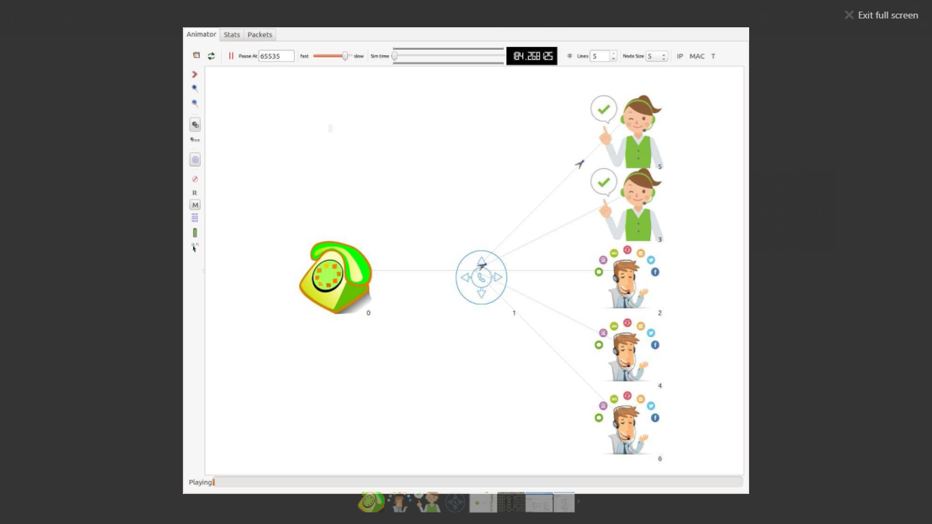

Figure 53: NetAnim Simulation

### Online Erlang C Calculator [2]

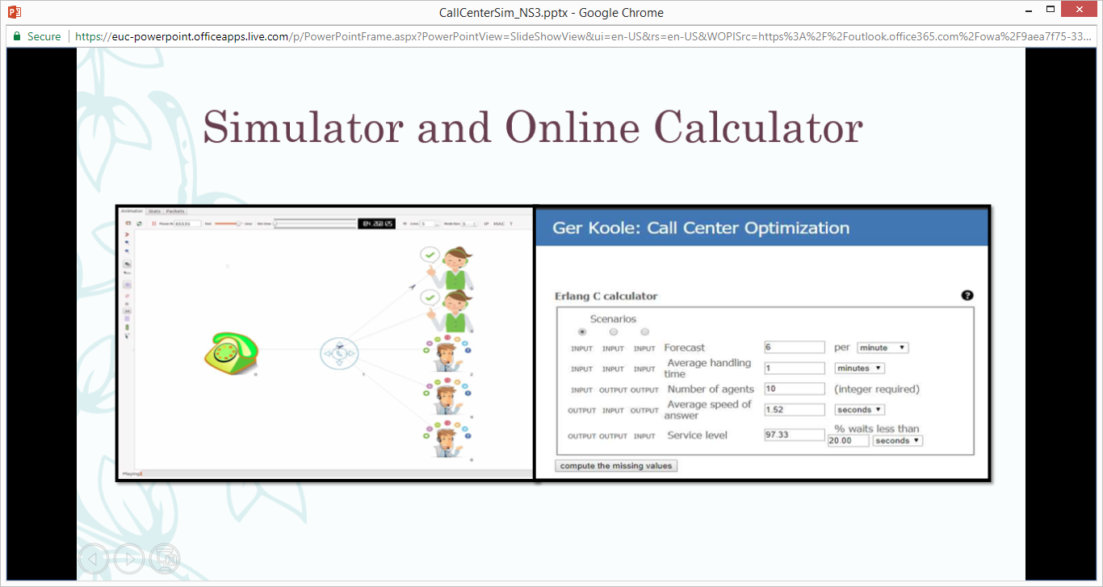

Figure 54: Erlang C Calculator

### Online Erlang X Calculator [3]

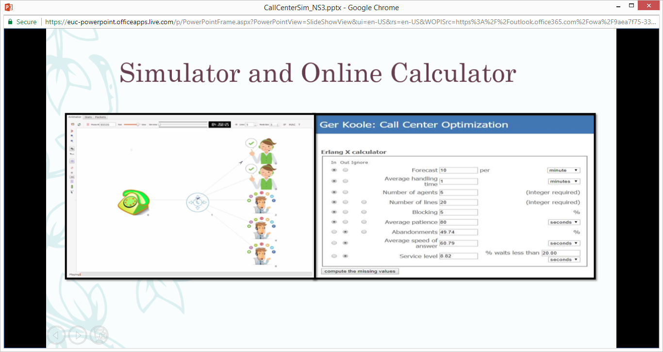

Figure 55: Erlang X Calculator

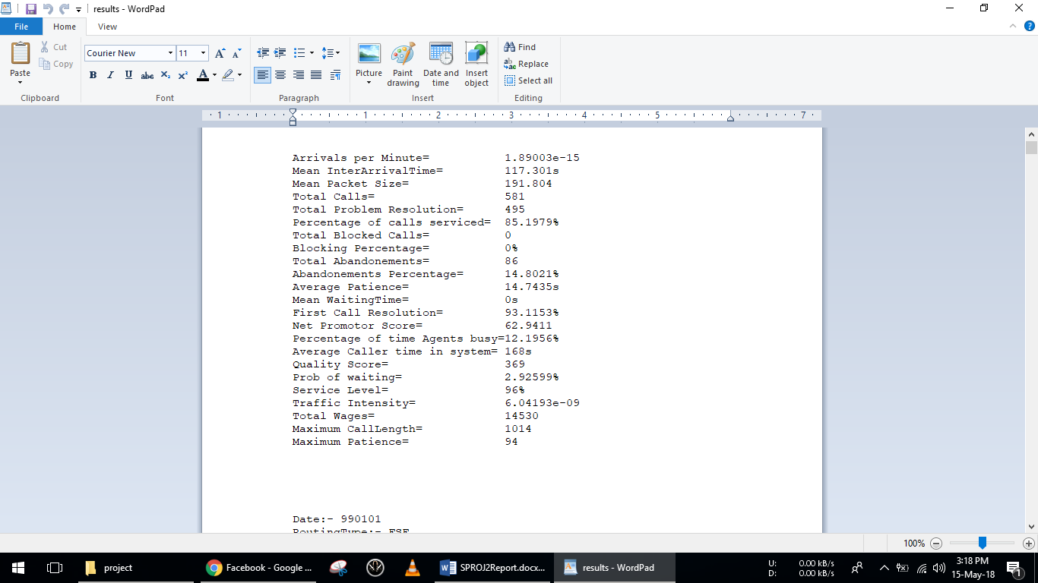

Figure 56: NS-3 Call Center Log File

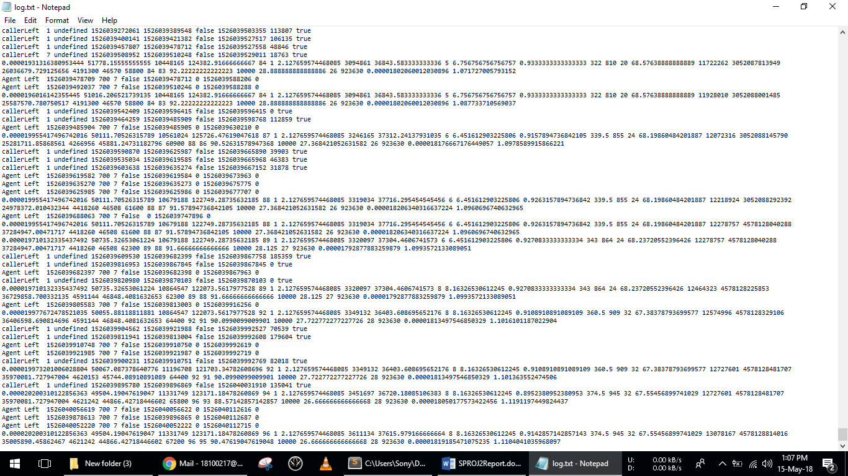

Figure 57: Node.js Call Center Log File

### **NS-3 Code**

#include "ns3/core-module.h"

#include "ns3/network-module.h"

#include "ns3/internet-module.h"

#include "ns3/point-to-point-module.h"

#include "ns3/applications-module.h"

#include "ns3/netanim-module.h"

#include "ns3/animation-interface.h"

#include "ns3/ipv4-address-helper.h"

#include "ns3/internet-stack-helper.h"

#include "ns3/ipv4-global-routing-helper.h"

#include "ns3/ipv4-global-routing.h"

#include "ns3/callback.h"

#include "ns3/point-to-point-helper.h"

#include "ns3/simulator.h"

#include <string>

#include <cstring>

#include <sstream>

#include <iostream>

#include <fstream>

using namespace ns3;

using namespace std;

ofstream myfile;

int Mean_InterArrival_Time =5;

int Mean_Packet_Size =50;

int Mean_Patience =60;

int number_of_Agent_nodes =5;

int simtime =86500;

int randm =1;

int Maximum_Queue_Length =20;

uint32_t WagePerCall =100;

uint32_t AverageServiceTime =45;

double precision =1;

uint32_t meanskill =31;

uint32_t meanVRUTime =10;

int RoutingType =4;//1-SBR, 2-FSF, 3-LIF, 4-LCR

int MaxCallsPerHour =0;

uint32_t TotalWages =0;

double MaxCallLength =0;

int **TABLE =new int * [25];

bool * idleArray =new bool [number_of_Agent_nodes];

bool * Servicing =new bool [number_of_Agent_nodes];

uint32_t * SkillArray =new uint32_t[number_of_Agent_nodes];

uint32_t * WagesArray =new uint32_t[number_of_Agent_nodes];

uint32_t * AvgServiceTimeArray =new uint32_t[number_of_Agent_nodes];

uint32_t *TimeOfLastServiceArray=new uint32_t[number_of_Agent_nodes];

string **TEMP3 =new string*[90000];

string **AVAIL_AGENT =new string*[90000];

int **AG_SER =new int *[90000];

string *TEMP =new string [90000];

string *ENTRYTIME =new string [90000];

int *VRU_ENTRY =new int [90000];

string *ordered =new string [90000];

Ptr<Node> DistributorN;

### Distributor Queue

class DistributorQueue{

public:

DistributorQueue(int m,AnimationInterface* anim)

{…}

struct Link

{

Link * Back;

Link * Front;

uint32_t Data;

uint32_t Skill;

Ptr<Packet> pkt;

Time EnqueueTime;

uint32_t QueueWaitingTime;

uint32_t VRUtime;

};

void Enqueue(Ptr<Packet> packet)

{…}

void CountDown()

{…}

void VRUEnqueue(Ptr<Packet> packet,uint32_t VRUTime)

{…}

void VRUCountDown(DistributorQueue * queue)

{…}

Ptr<Packet> Dequeue()

{…}

Link * Head;

Link * Tail;

Link * MyLink;

AnimationInterface* MyAnimator;

int TotalPackets,NumberOfPacketsInQueue,TotalPacketsDequeued,MaximumQueueLimit;

};

### Caller Application

class CallerApp:public Application{

public:

CallerApp()

{…}

void Setup(Ptr<Socket> mysocket, Address address,uint32_t meantime, uint32_t meansize, uint32_t meanwaitingtime, uint32_t minskill, uint32_t boundskill)

{…}

void StartApplication()

{…}

void StopApplication ()

{…}

void SetHourlyPacketInterArrivalTime()

{…}

void SendPacket()

{…}

Address peer;

EventId SendEvent;

EventId SendEvent1;

Ptr<Socket> socket;

int TotalPacketsSent;

Ptr<ExponentialRandomVariable> PacketSizeGenerator;

Ptr<ExponentialRandomVariable> SkillTypeGenerator;

Ptr<ExponentialRandomVariable> WaitingTimeGenerator;

Ptr<ExponentialRandomVariable> InterArrivalTimeGenerator;

uint32_t time,size,waitingtime,skill,myboundsize,myboundwaitingtime,myboundskill;

};

### Receiver Application

class ReceiverApp: public Application{

public:

ReceiverApp():peer(),MySocket(0)

{

VRUTimeGenerator =CreateObject<ExponentialRandomVariable>();

}

void Setup(Ptr<Socket> socket,Address Agentaddress,DistributorQueue* myqueue,int mypeernumber,uint32_t meanwaitingtime,DistributorQueue* VRUqueue)

{…}

void StartApplication()

{…}

void StopApplication ()

{…}

void SocketRecv(Ptr<Socket> socket)

{…}

void CountDown()

{…}

Address peer;

int PeerNumber;

EventId SendEvent;

uint32_t PacketSize;

Ptr<Packet> MyPacket;

Ptr<Socket> MySocket;

Ptr<ExponentialRandomVariable> VRUTimeGenerator;

DistributorQueue* queue;

DistributorQueue* VRUQueue;

uint32_t VRUtime;

};

### Distributor Application

class DistributorApp: public Application{

public:

DistributorApp():peer(),dataRate(0),MySocket(0){}

void Setup(Ptr<Socket> socket, DataRate datarate,Address Agentaddress,uint32_t* mySkillArray,DistributorQueue* myqueue,bool* myidle,int mypeernumber,AnimationInterface * anim)

{…}

void StartApplication()

{…}

void StopApplication ()

{…}

void SendPacket(int AgentNumber)

{…}

void swap(uint32_t* Arr,int a, int b)

{…}

uint32_t * SortMax(uint32_t Array[], int n)

{…}

//Fastest Server First Routing Scheme...

void FSF()

{…}

//Longest Idle First...

void LIF()

{…}

// Lowest Cost First routing Scheme..

void LCR()

{ …}

void SkillBasedRouting()

{…}

bool * idle;

Address peer;

int PeerNumber;

DataRate dataRate;

EventId SendEvent;

uint32_t PacketSize;

Ptr<Packet> MyPacket;

uint32_t * SkillArray;

Ptr<Socket> MySocket;

DistributorQueue* queue;

AnimationInterface* MyAnimator;

};

### Agent Application

class AgentApp:public Application{

public:

AgentApp()

{…}

void Setup(Ptr<Socket> socket,Address address, uint32_t myAgentskill,int myAgentnumber,AnimationInterface* animator,uint32_t pic1,uint32_t pic2, uint32_t wage, uint32_t AvgServiceTime)

{…}

void StartApplication()

{…}

void StopApplication ()

{…}

void SocketRecv(Ptr<Socket> socket)

{…}

void ServiceComplete()

{…}

Address peer;

uint32_t CallsRecieved_InADay; //......to model the exhaustion level.

uint32_t CallsRecieved_SinceJoined; //......to model the experience level.

uint32_t AverageServiceTime;

uint32_t WagePerCall; //......to model the wages.

uint32_t TimeOfLastService; //..... For Longest Idle First Routing scheme.

uint32_t TimeOfLastArrival; //..... For Longest Idle First Routing scheme.

uint32_t breaks; //......to model the .

uint32_t myp1;

uint32_t myp2;

int PacketsServed;

EventId SendEvent;

int AgentNumber;

uint32_t PacketSize;

Ptr<Socket> MySocket;

Ptr<Packet> MyPacket;

uint32_t AgentSkill;

AnimationInterface* mya;

//EFFICIENCY OF THE Agent.

uint32_t OP_Efficiency;

Ptr<ExponentialRandomVariable> EfficiencyGenerator;

};

### Main

NS_LOG_COMPONENT_DEFINE ("CallCenterSimulation");

int

main (int argc, char *argv[])

{

ifstream INSTREAM;

INSTREAM.open("january.txt");

ofstream o;

o.open("results.txt");

…

LogComponentEnable ("CallCenterSimulation", LOG_LEVEL_INFO);

NodeContainer caller_node_container;

NodeContainer distributor_node_container;

NodeContainer Agent_nodes_container;

caller_node_container. Create(1);

distributor_node_container. Create(1);

Agent_nodes_container. Create(number_of_Agent_nodes);

PointToPointHelper caller_distributor_p2p_Helper;

caller_distributor_p2p_Helper.SetDeviceAttribute ("DataRate", StringValue ("64kbps"));

caller_distributor_p2p_Helper.SetChannelAttribute("Delay" , StringValue ("3s" ));

NetDeviceContainer caller_distributor_net_device_container;

NetDeviceContainer distributor_Agents_net_device_container_Array[number_of_Agent_nodes];

caller_distributor_net_device_container = caller_distributor_p2p_Helper.Install (caller_distributor_nodes_container);

for(int i=0;i<number_of_Agent_nodes;i++){distributor_Agents_net_device_container_Array[i] = caller_distributor_p2p_Helper.Install (distributor_Agents_node_container[i]);}

InternetStackHelper stack;

Ipv4AddressHelper address;

stack .Install (c);

address.SetBase ("10.1.1.0", "255.255.255.0");

Ipv4InterfaceContainer interface =address.Assign (caller_distributor_net_device_container);

Ptr<Socket> CallerSocket = Socket::CreateSocket(c.Get(0) ,TypeId::LookupByName ("ns3::Ipv4RawSocketFactory"));

Ptr<Socket> DistributorSocket = Socket::CreateSocket(c.Get(1) ,TypeId::LookupByName ("ns3::Ipv4RawSocketFactory"));

Ptr<Socket> AgentSocketArray [number_of_Agent_nodes];

Ptr<Socket> DistributorSocketArray[number_of_Agent_nodes];

AnimationInterface* anim = new AnimationInterface ("anim1.xml");

DistributorQueue q =DistributorQueue(Maximum_Queue_Length,anim);

DistributorQueue* queue = &q;

DistributorQueue Q =DistributorQueue(1000,anim);

DistributorQueue* VRUqueue = &Q;

Ptr<CallerApp> capp = CreateObject<CallerApp> ();

Ptr<ReceiverApp> rapp = CreateObject<ReceiverApp> ();

for (int i = 0; i < number_of_Agent_nodes; i++)

{

Ptr<AgentApp> Oapp =CreateObject<AgentApp> ();

c.Get (i+2)->AddApplication (Oapp);

Ptr<DistributorApp> Dapp=CreateObject<DistributorApp>();

c.Get (1) ->AddApplication (Dapp);

}

Ipv4GlobalRoutingHelper Router = Ipv4GlobalRoutingHelper();

Router.PopulateRoutingTables();

Simulator::Stop (Seconds (simtime));

Simulator::Run ();

NS_LOG_INFO("Ending Topology");

Simulator::Destroy ();

myfile.close();

…

out<<"Arrivals per Minute="<<60/((double(sum2)/double(calls-1))/1e6)<<endl;

out<<"InterArrivalTime="<<((double(sum7)/double(calls)))<<"s"<<endl;

out<<"Mean Packet Size="<<(double(sum4)/double(calls)) <<endl;

out<<"Blocking Percentage="<<((double(Drops)*100)/double(calls))<<"%"<<endl;

out<<"Average Patience="<<(double(sum5)/double(calls)) <<"s"<<endl;

out<<"Abandonements Percentage="<<((double(Abandonements)*100)/double(calls)) <<"%"<<endl;

out<<"Mean WaitingTime="<<(double(mean)/1e6) <<"s"<<endl;

out<<"Total Calls="<< calls<<endl;

out<<"Total Problem Resolution="<< totalcalls<<endl;

out<<"Percentage of calls serviced="<< ((double(calls)-double(Abandonements)-double(Drops))/double(calls))*100<<"%"<<endl;

out<<"First Call Resolution="<< ((double(calls)-double(prob))/double(calls))*100<<"%"<<endl;

out<<"Net Promotor Score="<<(((double(Promoter)-double(Detractor)))/(double(Promoter)+double(Passive)+double(Detractor)))*100<<endl;

out<<"Utilization="<<((double(totalcalls)*(double(sum4)/double(calls)))/(double(simtime*number_of_Agent_nodes)))*100<<"%"<<endl;

out<<"Average Caller time in system= "<<(double(avgCalTime)) <<"s"<<endl;

out<<"Total Agents Salary="<<(double((var/3600)*HourlyWage)) <<"Rs"<<endl;

out<<"Quality Score="<<(double(QS)) <<endl;

out<<"Prob of waiting="<<(double(pep)/double(calls))*100<<"%"<<endl;

out<<"Service Level="<<double(servicelevel) <<"%"<<endl;

out<<"Traffic Intensity="<<(double(double(calls-1)*1000000)/((double(sum2))))*(double(sum4)/double(calls)) <<endl;

out<<"Total Wages="<<TotalWages<<endl;

out<<"MaxCallLength="<<MaxCallLength<<endl;

return 0;

o.close();

}

### **Node.js Code**

### App.js

var fs = require('fs');

var os = require("os");

var sios = require('socket.io');

var http = require('http');

var https = require('https');

var callarray = [];

var agentarray = [];

var MaxQueueTime = 0;

var infoObj = {CallersNo:0, AgentsNo:0};

var StartTime = Date.now();

var ArriPerSec = 0;

var InterArriTime = 0;

var TotalServicTime = 0;

var MeanCalltime = 0;

var TotalCallServ = 0;

var Drops = 0;

var BlockPercen = 0;

var TotalQueueTime = 0;

var AvgQueTime = 0;

var Abandon = 0;

var AbandonPercen = 0;

var PercenCallServ = 0;

var Passive = 0;

var Promoter = 0;

var Detractor = 0;

var NetPromoScore = 0;

var AgentAvail = 0;

var AgentBusy = 0;

var Utilization = 0;

var TotCallerTime = 0;

var AvgCallerTime = 0;

var AgenSalary = 0;

var QualityScores = 0;

var Wait = 0;

var ProbWait = 0;

var SevicThresh = 10000;

var ServiceLevel = 0;

var CorreServiced = 0;

var MaxCallLen = 0;

var ServiceRate = 0;

var TrafficIntens = 0;

var logString="";

const options = {

key: fs.readFileSync('./ryans-key.pem'),

cert: fs.readFileSync('./ryans-cert.pem')

};

var app = https.createServer(options, (req, res) => {

if (req.url === '/')

{fs.readFile('CallCentre.html', function(error,data){res.end(data);})}

if ((req.url === '/Caller')||(req.url === '/caller'))

{fs.readFile('caller.html', function(error,data){res.end(data);})}

if ((req.url === '/Agent')||(req.url === '/agent'))

{fs.readFile('agent.html', function(error,data){res.end(data);})}

});

app.listen(8000,'192.168.1.4');

const io = sios.listen(app);

function Routing()

{…}

function SendToPeer(Socket,Tag, Message)

{…}

fs.readFile("log.txt", 'utf8', function (err,data)

{…});

function logfile()

{…}

setInterval(logfile,60000);

io.on('connection', function (socket) {

socket.on('disconnect', function(){…});

socket.on('offer',function(offer){… Routing(); });

socket.on('Type', function (data) {… Routing(); } );

socket.on('answer',function(answer){SendToPeer(socket,'answer',answer);});

socket.on('CompleteFileReceived',function(){SendToPeer(socket,"CompleteFileReceived","")});

socket.on('TextMessage', function(Message){SendToPeer(socket, 'TextMessage', Message);});

socket.on('iceCandidate', function(candidate){ SendToPeer(socket,"iceCandidate", candidate );});

socket.on('fileInformation',function(fileInformation) {SendToPeer(socket,'fileInformation',fileInformation)});

socket.on('StartSendingFile',function(StartSendingFile) {SendToPeer(socket,'StartSendingFile',StartSendingFile)});

});

### Caller.html

<!DOCTYPE HTML>

<html>

<head> …

<h1>Caller</h1>

<script src="/socket.io/socket.io.js"></script>

</head>

<body>

<div>

<audio id = "LocalVideo"></audio>

<button id = "CallButton">CALL</button>

<a>Hang Up</a>

</div>

<div>

<textarea id = "sent"></textarea>

<button>Send Text</button>

<form><input type="file"></input></form>

<select id="BandwidthList"></select>

<canvas id="localcanvas”></canvas>

<textarea id="ByteRecieved"></textarea>

</div>

<div>

<canvas id="remotecanvas"></canvas>

<audio id = "RemoteVideo"></audio>

<textarea id = "received"></textarea>

<a id = "download">noFile</a>

<video> </video>

<img></img>

</div>

<div>

<p>Name:</p>

<textarea id="NameText"></textarea>

<p>Codec:</p>

<select id="CodecList">Choose Codec</option> </select>

<p>Skill:</p>

<select id="SkillSet"></select>

</div>

<script>

var socket = io();

var ReceiveText;

var pc1 = new RTCPeerConnection(servers);

var localStream;

var sendChannel;

var offerOptions = {offerToRecieveAudio:1,offerToRecieveVideo:0,voiceActivityDetection:false};

var fileInput = document.getElementById('fileInput');

var receiveChannel;

var receiveBuffer = [];

var receivedSize = 0;

var FileName;

var sendChannel;

var downloadAnchor = document.getElementById('download');

var recieveVideo = document.getElementById('recieveVideo');

var recieveImage = document.getElementById('recieveImage');

var SkillSet = document.getElementById("SkillSet");

var CallButton = document.getElementById("CallButton");

var TextButton=document.getElementById("TextButton");

var fileInput=document.getElementById("fileInput");

var bandwidthSelector=document.getElementById("BandwidthList");

var codecSelector=document.getElementById("CodecList");

var SignInForm=document.getElementById("SignInForm");

var localcanvas=document.getElementById("localcanvas");

var remotecanvas=document.getElementById("remotecanvas");

socket.connect();

socket.on('Information', function(data){…});

socket.on('TextMessage',function(data){…});

socket.on('answer',function(answer){…);

socket.on('iceCandidate',function(candidate){…});

socket.on('fileInformation',function(fileInformation){…));

socket.on('StartSendingFile',function(StartSendingFile){…});

socket.on("CompleteFileReceived",function(){…})

pc1.onicecandidate = function(e) {…};

pc1.ontrack = gotRemoteStream;

pc1.ondatachannel = receiveChannelCallback;

sendChannel = pc1.createDataChannel('sendDataChannel');

// functions...................

function SkillChosen() {…}

function gotStream(Stream){…}

function displayStates() {…}

function myfunc(){…}

function CallButtonPressed(){…}

function gotDescription1(desc) {…}

function onIceCandidate(event){… }

function FileChosen() {…}

function onSendChannelStateChange() {…}

function gotRemoteStream(event){…}

function SendData() {…}

function receiveChannelCallback(event) {…}

function onReceiveMessageCallback(event) {…}

function BandwidthChosen(){…}

function updateBandwidthRestriction(sdp, bandwidth) {…}

function getCodecPayloadType(sdpLine) {…}

function setDefaultCodec(mLine, payload) {…}

function codecChosen(){…}

function StreamVisualizer(remoteStream, canvas) {…}

StreamVisualizer.prototype.start = function() {…};

StreamVisualizer.prototype.draw = function() {…};

StreamVisualizer.prototype.getFrequencyValue = function(freq) {…};

</script>

</body>

</html>

### Agent.html

<!DOCTYPE HTML>

<html>

<head>

<h1>Agent</h1>

<script src="/socket.io/socket.io.js"></script>

</head>

<body>

<div>

<audio id = "LocalVideo"></audio>

<button>Pick Up</button>

<div>

<a id = "Hang Up">Hang Up</a>

</div>

<textarea></textarea>

<button>Send Text</button>

<form onchange="FileChosen()"><input type="file"></form>

<textarea id= "ByteRecieved"></textarea>

<canvas id="localcanvas"></canvas>

</div>

<div>

<canvas></canvas>

<audio></audio>

<textarea></textarea>

<a></a>

<video></video>

<img></img>

</div>

<div>

<p>Name:</p>

<textarea></textarea>

<p>Skill:</p>

<select id="SkillSet"></select>

</div>

<script>

var socket = io();

var InfoObj ={};

var servers = null;

var receiveChannel;

var receiveBuffer = [];

var receivedSize = 0;

var Remotestream;

var pc2 = new RTCPeerConnection(servers);

var offerOptions = {offerToRecieveAudio:1,offerToRecieveVideo:0,voiceActivityDetection:false};

var downloadAnchor = document.getElementById('download');

var FileName;

var FileSize=0;

var sendChannel;

var fileInput = document.getElementById('fileInput');

var recieveVideo = document.getElementById('recieveVideo');

var recieveImage = document.getElementById('recieveImage');

var ByteRec = document.getElementById('ByteRecieved');

var SkillSet=document.getElementById("SkillSet");

var PickupCallButton=document.getElementById("PickupCallButton");

var TextButton=document.getElementById("TextButton");

var SignInForm=document.getElementById("SignInForm");

var NameText=document.getElementById("NameText");

var localcanvas=document.getElementById("localcanvas");

var remotecanvas=document.getElementById("remotecanvas");

socket.connect();

socket.on('Information', function(data){…});

socket.on('TextMessage',function(data){…});

socket.on('offer',function(offer){…});

socket.on('iceCandidate',function(candidate){…});

socket.on('StartSendingFile',function(StartSendingFile){SendData();});

socket.on("CompleteFileReceived",function(){fileInput.disabled=false;})

pc2.onicecandidate = function(e) {console.log('Local IceCandidate received'+JSON.stringify(e));onIceCandidate(e);};

pc2.ontrack = gotRemoteStream;

pc2.ondatachannel = receiveChannelCallback;

sendChannel = pc2.createDataChannel('sendDataChannel');

sendChannel.binaryType = 'arraybuffer';

sendChannel.onopen = onSendChannelStateChange;

function PickupCall(){…}

function SkillChosen() {…}

function displayStates() {…};

function gotDescription2(desc) {…}

function gotStream(Stream){…}

function receiveChannelCallback(event) {…}

function onReceiveMessageCallback(event) {…}

function onIceCandidate(event){…}

function gotRemoteStream(event){…}

function FileChosen() {…}

function onSendChannelStateChange() {…}

function SendData() {…}

function StreamVisualizer(remoteStream, canvas) {…};

StreamVisualizer.prototype.draw = function() {…};

StreamVisualizer.prototype.getFrequencyValue = function(freq) {…};

</script>

</body>

</html>

### CallCenter.html

<!DOCTYPE HTML>

<html>

<head>

<div>

<h1 style="font-size: 50px;color: rgb(0,0,0);">CallCenter</h1>

</div>

</head>

<body style="background-image: url(); background-repeat: no-repeat; background-position: 300px 50px; ;background-size: 800px 700px;">

<div>

<a href="https://192.168.1.4:8000/Caller">Visit Caller page</a>

</div>

<div>

<a href="https://192.168.1.4:8000/agent">Visit Agent page</a>

</div>

</body>

</html>